

City Book Shop

Object Oriented Programming



August 16, 2021

MN RIZNI MOHAMED

JF HDCSE CMU 09 21

ST 20195902

**Assignment Cover Sheet**

|  |  |  |  |
| --- | --- | --- | --- |
| **Qualification** | | **Module Number and Title** | |
| HD in Computing and Software Engineering | | **OOP-** CSE4006 | |
| **Student Name & No.** | | **Assessor** | |
| MN RIZNI MOHAMED  JF HDCSE CMU 09 21  ST 20195902 | | Miss Ushamini Kulas | |
| **Hand out date** | | | **Submission Date** |
| 13/06/2021 | | | 21/8/2021 |
| **Assessment type**  WRIT1-Coursework | **Duration/Length of**  **Assessment Type**  3000 wordsequivalent | | **Weighting of Assessment**  100% |

|  |  |
| --- | --- |
| **Learner declaration** | |
| I certify that the work submitted for this assignment is my own and research sources are fully acknowledged. | |
| |  |  |  |  | | --- | --- | --- | --- | | **Marks Awarded** | | | | | First assessor | |  | | | IV marks | |  | | | Agreed grade | |  | | | Signature of the assessor |  | Date |  | |

**Feedback Form**

**International College of Business & Technology**

**Module:** OOP - CSE4006

**Student:** MN RIZNI MOHAMED JF HDCSE CMU 09 21 ST 20195902

**Assessor:** Miss Ushamini Kulas

**Assignment:** Object oriented programming

**Strong features of your work:**

**Areas for improvement:**

**Marks Awarded:**

**Acknowledgement**

In the first place, I'd want to thank God Almighty and my parents for their encouragement and support. Our sincere gratitude goes out to Miss Ushamini Kulas, who educated us and supervised us throughout this process. It would not have been possible without their invaluable assistance and valuable experience. Apart from that, I'd want to express our gratitude to the ICBT administration for granting us permission and providing us with space to finish our project. Last but not least, I apologize to everyone else who assisted us in many ways to have a nice time.

**List of Contents**

City Book Shop 1

1. Introduction 1

2. Objectives of the system 1

3. Design of solution 2

3.1. Use case diagram 2

3.1.1. City bookshop use-case diagram 2

3.2. Class diagram 4

3.2.1. City bookshop use case diagram 4

3.3. Sequence diagram 6

3.3.1. Create account 7

3.3.2. Delete account 8

3.3.3. Search account 9

3.3.4. Update account 10

3.3.5. Create book 11

3.3.6. Delete book 12

3.3.7. Delete book category 13

3.3.8. Search book 14

3.3.9. Update book 15

3.3.10. View all book category 16

3.3.11. Create invoice 17

3.3.12. Print invoice 18

3.3.13. Search book 19

3.3.14. Book inventory 20

3.3.15. Daily sales 21

3.3.16. Monthly sales 22

3.3.17. Delete invoice 23

3.3.18. Search invoice 24

3.3.19. Update invoice 25

3.3.20. Login 26

3.3.21. Logout 27

3.3.22. Reset password 28

4. Development 29

4.1. Development environment 29

4.2. Module structure of the system 30

4.3. Reusable components 30

4.4. Object oriented programming 31

4.4.1. Object 31

4.4.2. Class 34

4.4.3. Inheritance 37

4.4.4. Encapsulation 41

4.4.5. Polymorphism 43

4.4.6. Abstraction 47

5. User manual 49

5.1. Prerequisites 49

5.2. Login page 50

5.3. Forget password page 52

5.4. Reset password page 53

5.5. Dashboard page 54

5.6. Invoice management page 55

5.7. Transaction management page 56

5.8. Book management page 58

5.9. Account management page 60

5.10. Statistics page 62

6.Test summery report 64

7. Future recommendation 64

Gantt chart 65

Plagiarism report 66

Reference 70

**List of Tables**

Table 1 Main requirements 1

Table 2 Other requirements 1

Table 3 Sub systems and functionalities 3

Table 4 Package name and class name 5

Table 5 Sequence diagram use case specification 7

Table 6 Hardware, software and libraries 29

**List of Figures**

Figure 1 Use-case diagram 2

Figure 2 Class diagram 4

Figure 3 Sequence diagram create account 7

Figure 4 Sequence diagram - delete account 8

Figure 5 Sequence diagram - Search account 9

Figure 6 Sequence diagram - Update account 10

Figure 7 Sequence diagram - Create book 11

Figure 8 Sequence diagram - Delete book 12

Figure 9 Sequential diagram - Delete book category 13

Figure 10 Sequential diagram - search book 14

Figure 11 Sequence diagram - Update book 15

Figure 12 Sequence diagram - view all book details 16

Figure 13 Sequence diagram - Create invoice 17

Figure 14 Sequence diagram - Print invoice 18

Figure 15 Sequence diagram - Search book 19

Figure 16 Sequence diagram - Book inventory 20

Figure 17 Sequence diagram - Daily sales 21

Figure 18 Sequence diagram - Monthly sales 22

Figure 19 Sequence diagram - Delete invoice 23

Figure 20 Sequence diagram - Search invoice 24

Figure 21 Sequence diagram - Update invoice 25

Figure 22 Sequence diagram – Login 26

Figure 23 Sequence diagram – logout 27

Figure 24 Module structure of the system 30

Figure 25 Reusable components 30

Figure 26 Anonymous object – general syntax 31

Figure 27 Anonymous object - example 1 32

Figure 28 Anonymous object - example 2 32

Figure 29 Anonymous object - example 3 32

Figure 30 Known object - general syntax 33

Figure 31 Known object - example 1 33

Figure 32 Known object - example 2 34

Figure 33 Regular class - General syntax 35

Figure 34 Login class – example 1 35

Figure 35 DBConnection - example 2 35

Figure 36 dashboardController - example 3 36

Figure 37 Inner class - general syntax 36

Figure 38 Anonymous class - general syntax 37

Figure 39 Single level inheritance - general syntax 38

Figure 40 Single level inheritance - Example 1 38

Figure 41 Single level inheritance - example 2 39

Figure 42 Single level Inheritance - example 3 39

Figure 43 multi-level inheritance - general syntax 40

Figure 44 Hierarchical inheritance - general syntax 40

Figure 45 Multiple inherence - general syntax 41

Figure 46 Encapsulation - general syntax 41

Figure 47 Encapsulation - example 1 42

Figure 48 Encapsulation - example 2 42

Figure 49 Encapsulation - example 3 43

Figure 50 Method overloading - general syntax 44

Figure 51 Method overloading - example 1 44

Figure 52 Method overloading - example 2 45

Figure 53 Method overriding - General syntax 45

Figure 54 Method overriding - example 1 46

Figure 55 Method overriding - example 2 46

Figure 56 Method overriding - example 3 47

Figure 57 Abstraction - General syntaxe 47

Figure 58 Abstraction - example 1 48

Figure 59 Environment variables 49

Figure 60 Edit environment variables 49

Figure 61 Login page 50

Figure 62 Forget password page 52

Figure 63 Reset password page 53

Figure 64 Dashboard page 54

Figure 65 Invoice management page 55

Figure 66 Transaction management page 56

Figure 67 Book management page 58

Figure 68 Account management page 60

Figure 69 Statistics page 62

Figure 70 Test summery report 64

Figure 71 Gantt chart 65

Figure 72 Plagiarism report - page 1 66

Figure 73 Plagiarism report - page 2 67

Figure 74 Plagiarism report - page 3 68

Figure 75 Plagiarism report - page 4 69

# City Book Shop

## 1. Introduction

City book shop is the well-known bookshop in Puttalam. There are several kinds books available in affordable price. Due to higher number of customers visit they face difficulties in transaction management. Therefore, they decided to automate the entire transaction system. They come with for create a software for all transaction management process.

## 2. Objectives of the system

Main objective of this system is automating and computerize entire transaction system to manage customer traffic in efficient manner. For that creating a software which include various features according employee’s needs. There are two types of employees working in city book shop. Those are admin and cashier. Each type of employee has different task respective to their job role.

Main requirements:

|  |  |
| --- | --- |
| **Cashier** | **Admin** |
| View all book details | View all book details |
| Add new book details and category | Add new book details and category |
| Search book details based on category, Name, Price. | Search book details based on category, Name, Price. |
|  | Create accounts |

Table 1 Main requirements

Other requirements:

|  |  |
| --- | --- |
| **Cashier** | **Admin** |
| View Statistics | View Statistics |
| Login and forget password | Login and forget password |
| Create, view, search invoice | Create, view, delete, update search invoice |
| Update, view own account | Update, search, view, delete accounts |

Table 2 Other requirements

## 3. Design of solution

All architectural modules and the communication and flow representation with the external and third-party modules are explicitly defined in a design approach (if any). In the design document specification, the internal design of all modules of the proposed architecture should be fully specified with the greatest possible detail (DDS).

(SDLC - Overview, 2021)

### 3.1. Use case diagram

The dynamic conduct of a system is represented by a use case diagram. It embodies the functioning of the system through the integration of use cases, actors and their relations. The system/subsystem of an application modeling the tasks, services and functions that are required. It shows the system's high-level capabilities and how the user manages a system as well.

(UML Use Case Diagram - Javatpoint, 2021)

#### 3.1.1. City bookshop use-case diagram

Double click the picture for view in Microsoft Viso for clear visuals



Figure 1 Use-case diagram

Assumptions:

* Admin and cahier have an account
* Admin and cashier have email addresses
* System has proper internet connection

Above use case diagram depicts the subsystems of city bookshop and system features. And also, it shows the capacities of employees according to their job roles. City book shop have 6 subsystems in it for perming their tasks. Those are Invoice management, Transaction management, Book management, Account management, Statistics and finally User authentication. Each subsystem has several functionalities related that system process. Those functionalities listed in below. See table 3.

|  |  |
| --- | --- |
| **Subsystem** | **Functionalities** |
| Invoice management | Create an invoice, Search book, print an invoice |
| Transaction management | Update an invoice, Search an invoice, Delete an invoice |
| Book management | Create book/category, Update book, Search book, view all books, Delete book, Delete book category |
| Account management | Update an account, create an account, Search an account, Delete an account |
| Statistics | View book inventory status, view monthly sale details, view daily status |
| User authentication | Login, logout, forget password |

Table 3 Sub systems and functionalities

In the invoice management admin/cashier can search a book by book’s name, book’s category, book’s unit price. In transaction management admin/cashier can search a invoice by book’s category, quantity, invoice’s ID, book’s name, total price and date. In book management admin/cashier can search a book by book’s name, book’s category, book’s unit price, book’s stock quantity and book’s ID. In account management admin can search a account by account type, account ID, username, name and email address. In statistics system, admin/cashier can view book inventory details by selecting book category, also they can view monthly sales details by selecting year and can view daily sale’s details by selecting a date. Finally, in user authentication if admin or cashier forget their password then can reset their password via reset password protocol. For confirming the user, for their email address an verification code will be send then they have to enter same code as they got via email in the system then they can set new password for their account

A cashier has the access to all features of user authentication system, statistics system, invoice management system. But for the security purpose cashier has access to some features in other systems. In the transaction management cashier has the access to search invoice only. In the book management system cashier has the access to create book/category, update book, search book, view all book details. In the account management cashier has the access to update their own account only

An admin has the full access to the system. So, admin inheriting all the access from cashier and additional to that in transaction management an admin can update or delete the transaction. Like vise, in book management admin can delete the book and book category and in account management an admin can update, delete, search and view any account also an admin can create new type of user accounts

By this use case diagram, it helps to understand the motive of the system and objectives of the system. By this use case we can justify our developed which full filled the requirements or not.

### 3.2. Class diagram

Unified Modeling Language (UML) class diagrams are static structural diagrams that depict the system's classes, attributes, actions (or methods), and connections between classes.

#### 3.2.1. City bookshop use case diagram

Click the picture while pressing ctrl key for view in clear visuals.

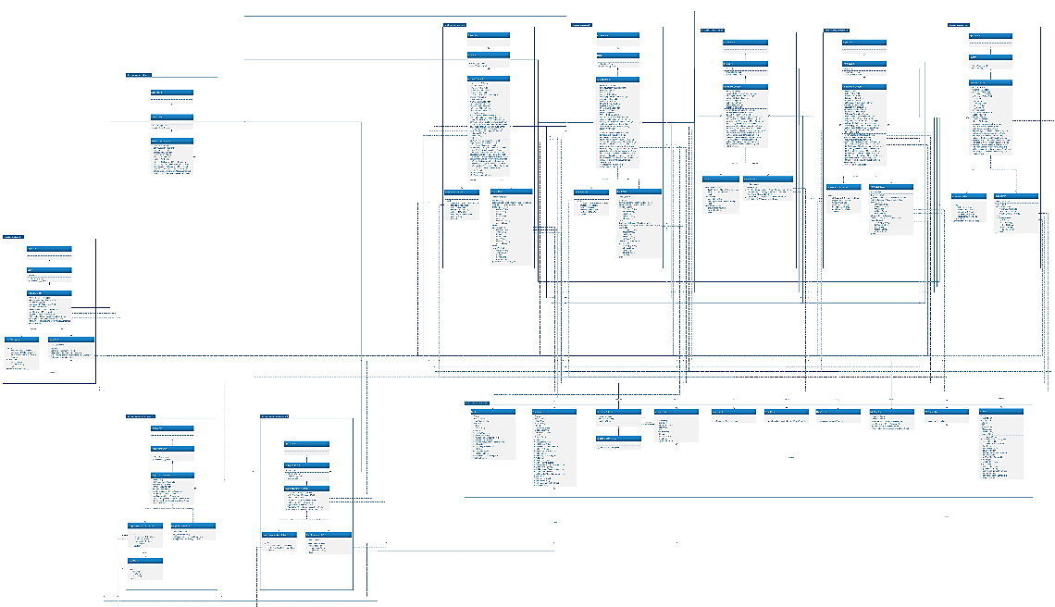

Figure 2 Class diagram

Assumptions:

* All system classes are inherited
* All external libraries such as MySQL connecter, JavaFX are associated

The above class diagram shows, there are 10 packages in this system and each packages consist several classes in it. Those are clearly mentioned in below table.

|  |  |
| --- | --- |
| **Package name** | **Class name** |
| rizni.bookshop.login | Application, Login, loginController, LoginDAO, LoginValidation |
| rizni.bookshop.forgetpassword | Application, Forgetpassword, forgetpassController, ForgetPasswordValidation, ForgetPasswordDAO, SendMail |
| rizni.bookshop.resetpassword | Application, ResetPassword, resetpasswordController, ResetPasswordValidation, ResetPasswordDAO |
| rizni.bookshop.dashborad | Application, Dashboard, dashboardController |
| rizni.bookshop.reuseable | Books, Employee, LoginInDetails, LoginInDetailsDAO, MessageBox, NumberUtils, UserPicture, WinTitleBar, DBConnection, Invoice |
| rizni.bookshop.invoice | Application, Invoice, invoiceController, InvoiceValidation, InvoiceDAO |
| rizni.bookshop.transaction | Application, Transaction, TransactionDAO, transactionController, TransactionValidation |
| rizni.bookshop.statistics | Application, Statistics, statisticsController, Charts, StatisticsDAO |
| rizni.bookshop.book | Application, Book, bookController, BookValidation, BookDAO |
| rizni.bookshop.forgetpassword | Application, Account, accountController, AccountValidation, AccountDAO |

Table 4 Package name and class name

The program starts with login unit. When user enter correct username and password then it’s moved into the dashboard unit. When user forget the password then it goes to forget password unit for the verification process and then it goes to resetpassword unit for set new password and finally it will go for dashboard unit. There is a reusable unit for the reusable components. Those components have use dependency with other unit’s classes. Dashboard, reusable, invoice, transaction, statistics, book, forgetpassword units are have interconnection with themselves which can lead users to go between these units and additionally it leads to login unit too. All the unit’s main class is inherited to the Application class and all controller classes are composite to their main class because without main class there is no life cycle for controller classes and also without start function which coming from Application, JavaFX will not start the application. And also, in reusable unit LoggedInUserDAO class inherit LoggedInUser class for access the variables.

By this class diagram, we can clearly get know about what are the classes are need to build this system and how to organize all the class within packages. And also, by this diagram we able to know how to declare the classes and what are the variables and methods need to declare in each class. So, this diagram gives clear picture about declarations.

### 3.3. Sequence diagram

As the name implies, it shows the order in which items interact with one other in a sequence diagram. Sequence diagrams can also be referred to as event diagrams or event scenarios. In a sequence diagram, the items in a system are described in terms of how they work and in what order. Businessmen and software engineers use these diagrams to document and understand requirements for new and current systems.

(Unified Modeling Language (UML) | Sequence Diagrams - GeeksforGeeks, 2021)

|  |  |  |
| --- | --- | --- |
| Subsystem | Use case ID | Use case |
| Account management | 3.3.1. | Create account |
| 3.3.2. | Delete account |
| 3.3.3. | Search account |
| 3.3.4. | Update account |
| Book management | 3.3.5. | Create book |
| 3.3.6. | Delete book |
| 3.3.7. | Delete book category |
| 3.3.8. | Search book |
| 3.3.9. | Update book |
| 3.3.10. | View all book category |
| Invoice management | 3.3.11. | Create invoice |
| 3.3.12. | Print invoice |
| 3.3.13. | Search book |
| Statistics | 3.3.14. | Book inventory |
| 3.3.15. | Daily sales |
| 3.3.16. | Monthly sales |
| Transaction management | 3.3.17. | Delete invoice |
| 3.3.18. | Search invoice |
| 3.3.19. | Update invoice |
| User authentication | 3.3.20. | Login |
| 3.3.21. | Logout |
| 3.3.22. | Reset password |

Table 5 Sequence diagram use case specification

#### 3.3.1. Create account

Double click the picture for view in Microsoft Viso for clear visuals



Figure 3 Sequence diagram create account

Assumptions:

* Database is created
* employee, login and role tables are created
* Admin have an account
* Admin logged in correct username and password

The above sequence diagram depicts about creating a new account in the system. Admin can create new type of account too. In first admin need to fill all filed in correct manner. For an example, account ID field cannot contain character values in that case it will throw error message to admin. And also, if any fields seemed to be empty or create option is not selected that time also it will throw error message. All the validating processes are held in AccountValidation class. This help to ensure the data accuracy. All the database query operations are done within AccountDAO class.

#### 3.3.2. Delete account

Double click the picture for view in Microsoft Viso for clear visuals



Figure 4 Sequence diagram - delete account

Assumptions:

* Database is created
* employee, login and role tables are created
* Admin have an account
* Admin logged in correct username and password

The above sequence diagram depicts about deleting an existing account from the system. Admin can only perform this task. In first admin need to fill all filed in correct manner. For an example, account ID field cannot contain character values in that case it will throw error message to admin. And also, if any fields seemed to be empty or delete option is not selected that time also it will throw error message. All the validating processes are held in AccountValidation class. This help to ensure the data accuracy. Also, it will ask confirmation to the admin for a second verification. It reduces the accidental data loss. All the database query operations are done within AccountDAO class.

#### 3.3.3. Search account

Double click the picture for view in Microsoft Viso for clear visuals



Figure 5 Sequence diagram - Search account

Assumptions:

* Database is created
* employee, login and role tables are created
* Admin have an account
* Admin logged in correct username and password

The above sequence diagram depicts about searching an existing account in the system. Admin can only perform this task. In first admin need to fill all filed in correct manner. For an example, account ID field cannot contain character values in that case it will throw error message. Also, if search option is not selected then it will throw error message. But if any fields seemed to be empty that time it will show all user according to user role permission. When everything is seemed to be correct then it will show searched user account details in the table. All the database query operations are done within AccountDAO class.

#### 3.3.4. Update account

Double click the picture for view in Microsoft Viso for clear visuals



Figure 6 Sequence diagram - Update account

Assumptions:

* Database is created
* employee, login and role tables are created
* Admin or cashier have an account
* Admin or cashier logged in correct username and password

The above sequence diagram depicts about updating an existing account in the system. Admin or cahier can only perform this task. In first admin or cashier need to fill all filed in correct manner. For an example, account ID field cannot contain character values in that case it will throw error message. And also, if any fields seemed to be empty or update option is not selected that time also it will throw error message. All the validating processes are held in AccountValidation class. This help to ensure the data accuracy. Also, it will ask confirmation to the admin or cashier for a second verification. It reduces the accidental data loss. Cashier can only update their own account but admin can update any account within the system. All the database query operations are done within AccountDAO class.

#### 3.3.5. Create book

Double click the picture for view in Microsoft Viso for clear visuals



Figure 7 Sequence diagram - Create book

Assumptions:

* Database is created
* book, book category, employee, login and role tables are created
* Admin or cashier have an account
* Admin or cashier logged in correct username and password

The above sequence diagram depicts about creating a new book in the system. Admin or cashier can create new book category too. In first they need to fill all fields in correct manner. For an example, book ID field cannot contain character values in that case it will throw error message. And also, if any fields seemed to be empty or create option is not selected that time also it will throw error message. All the validating processes are held in BookValidation class. This help to ensure the data accuracy. All the database query operations are done within BookDAO class.

#### 3.3.6. Delete book

Double click the picture for view in Microsoft Viso for clear visuals



Figure 8 Sequence diagram - Delete book

Assumptions:

* Database is created
* book, book category, employee, login and role tables are created
* Admin have an account
* Admin logged in correct username and password
* Some book’s details entered in the system

The above sequence diagram depicts about deleting an existing book from the system. Admin can only perform this task. In first admin need to fill all filed in correct manner. For an example, book ID field cannot contain character values in that case it will throw error message. And also, if any fields seemed to be empty or delete option is not selected that time also it will throw error message. All the validating processes are held in BookValidation class. This help to ensure the data accuracy. Also, it will ask confirmation to the admin for a second verification. It reduces the accidental data loss. All the database query operations are done within BookDAO class.

#### 3.3.7. Delete book category

Double click the picture for view in Microsoft Viso for clear visuals



Figure 9 Sequential diagram - Delete book category

Assumptions:

* Database is created
* book, book category, employee, login and role tables are created
* Admin have an account
* Admin logged in correct username and password
* Some book categorie’s details entered in the system

The above sequence diagram depicts about deleting an existing book category from the system. Admin can only perform this task. In first admin need to fill all filed in correct manner. For an example, book ID field cannot contain character values in that case it will throw error message. And also, if any fields seemed to be empty or delete book category option is not selected that time also it will throw error message. All the validating processes are held in BookValidation class. This help to ensure the data accuracy. Also, it will ask confirmation to the admin for a second verification. It reduces the accidental data loss. All the database query operations are done within BookDAO class.

#### 3.3.8. Search book

Double click the picture for view in Microsoft Viso for clear visuals



Figure 10 Sequential diagram - search book

Assumptions:

* Database is created
* book, book category, employee, login and role tables are created
* Admin or cashier have an account
* Admin or cashier logged in correct username and password
* Some book’s details entered in the system

The above sequence diagram depicts about searching an existing book in the system. Admin or cashier can perform this task. In first they need to fill all filed in correct manner. For an example, book ID field cannot contain character values in that case it will throw error message. Also, if search option is not selected then it will throw error message. But if any fields seemed to be empty that time it will show all book details. When everything is seemed to be correct then it will show searched user book details in the table. All the database query operations are done within BookDAO class.

#### 3.3.9. Update book

Double click the picture for view in Microsoft Viso for clear visuals



Figure 11 Sequence diagram - Update book

Assumptions:

* Database is created
* book, book category, employee, login and role tables are created
* Admin or cashier have an account
* Admin or cashier logged in correct username and password
* Some book’s details entered in the system

The above sequence diagram depicts about updating an existing book in the system. Admin or cahier can perform this task. In first admin or cashier need to fill all filed in correct manner. For an example, book ID field cannot contain character values in that case it will throw error message. And also, if any fields seemed to be empty or update option is not selected that time also it will throw error message. All the validating processes are held in BookValidation class. This help to ensure the data accuracy. Also, it will ask confirmation to the admin or cashier for a second verification. It reduces the accidental data loss. All the database query operations are done within BookDAO class.

#### 3.3.10. View all book category

Double click the picture for view in Microsoft Viso for clear visuals



Figure 12 Sequence diagram - view all book details

Assumptions:

* Database is created
* book, book category, employee, login and role tables are created
* Admin or cashier have an account
* Admin or cashier logged in correct username and password
* Some book’s details entered in the system

The above sequence diagram depicts about view all book details in the system. This can be done by cashier or admin. There is no validation process for this task. All available book details will be displayed in the table. All the database query operations are done within BookDAO class.

#### 3.3.11. Create invoice

Double click the picture for view in Microsoft Viso for clear visuals



Figure 13 Sequence diagram - Create invoice

Assumptions:

* Database is created
* invoice, employee, login and role tables are created
* Admin or cashier have an account
* Admin or cashier logged in correct username and password

The above sequence diagram depicts about creating a new invoice in the system. Admin or cashier can perform this task. In first they need to fill all fields in correct manner. For an example, invoice ID field cannot contain character values in that case it will throw error message. And also, if any fields seemed to be empty that time it will throw error message too. All the validating processes are held in InvoiceValidation class. This help to ensure the data accuracy. All the database query operations are done within InvoiceDAO class.

#### 3.3.12. Print invoice

Double click the picture for view in Microsoft Viso for clear visuals



Figure 14 Sequence diagram - Print invoice

Assumptions:

* Database is created
* invoice, employee, login and role tables are created
* Admin or cashier have an account
* Admin or cashier logged in correct username and password
* Printer is configured within the system
* Invoice is created successfully

The above sequence diagram depicts about printing the invoice details by printer via using the system. This can be done by cashier or admin. There is no validation process for this task. All invoice details will display in the window. All the database query operations are done within InvoiceDAO class. In success scenario it will show print dialog and when we click ok then it sent the file to printer que. From printer que it will print the invoice.

#### 3.3.13. Search book

Double click the picture for view in Microsoft Viso for clear visuals



Figure 15 Sequence diagram - Search book

Assumptions:

* Database is created
* Invoice, book, book category, employee, login and role tables are created
* Admin or cashier have an account
* Admin or cashier logged in correct username and password
* Some book’s details entered in the system

The above sequence diagram depicts about searching an existing book in the system for create an invoice. Admin or cashier can perform this task. In first they need to fill all filed in correct manner. For an example, if entered wrong book name in that case it will throw error message. also, if any fields seemed to be empty that time it will throw error message. When everything is seemed to be correct then it will show searched user book details in the table. All the database query operations are done within InvocieDAO class.

#### 3.3.14. Book inventory

Double click the picture for view in Microsoft Viso for clear visuals



Figure 16 Sequence diagram - Book inventory

Assumptions:

* Database is created
* Book, book category, employee, login and role tables are created
* Admin or cashier have an account
* Admin or cashier logged in correct username and password
* Some book’s details entered in the system

The above sequence diagram depicts about view book inventory details. Admin or cashier can perform this task. In the statistics page, initially all book categories and total number of books inside each category are will display in a pie chart. But admin or cashier can select a specific category for view books of particular book category. All the database query operations are done within StatisticsDAO class.

#### 3.3.15. Daily sales

Double click the picture for view in Microsoft Viso for clear visuals



Figure 17 Sequence diagram - Daily sales

Assumptions:

* Database is created
* Invoice, book, book category, employee, login and role tables are created
* Admin or cashier have an account
* Admin or cashier logged in correct username and password
* Some book’s details entered in the system
* Some invoices are made by admin or cashier

The above sequence diagram depicts about view daily details. Admin or cashier can perform this task. In the statistics page, initially all book categories and sum of sold book’s price inside each category are will display in a pie chart. But admin or cashier can select a specific day for view sold books and sum of total payment of particular day. All the database query operations are done within StatisticsDAO class.

#### 3.3.16. Monthly sales

Double click the picture for view in Microsoft Viso for clear visuals



Figure 18 Sequence diagram - Monthly sales

Assumptions:

* Database is created
* Invoice, book, book category, employee, login and role tables are created
* Admin or cashier have an account
* Admin or cashier logged in correct username and password
* Some book’s details entered in the system
* Some invoices are made by admin or cashier

The above sequence diagram depicts about view monthly details. Admin or cashier can perform this task. In the statistics page, initially sum of sold book’s price in each month of current year will display in a line chart. But admin or cashier can select a specific year for view details of particular year. All the database query operations are done within StatisticsDAO class.

#### 3.3.17. Delete invoice

Double click the picture for view in Microsoft Viso for clear visuals



Figure 19 Sequence diagram - Delete invoice

Assumptions:

* Database is created
* Invoice, employee, login and role tables are created
* Admin have an account
* Admin logged in correct username and password
* Some invoice details entered in the system

The above sequence diagram depicts about deleting an existing invocie from the system. Admin can only perform this task. In first admin need to fill all filed in correct manner. For an example, invcoie ID field cannot contain character values in that case it will throw error message. And also, if any fields seemed to be empty or delete option is not selected that time also it will throw error message. All the validating processes are held in InvoiceValidation class. This help to ensure the data accuracy. Also, it will ask confirmation to the admin for a second verification. It reduces the accidental data loss. All the database query operations are done within InvoiceDAO class.

#### 3.3.18. Search invoice

Double click the picture for view in Microsoft Viso for clear visuals



Figure 20 Sequence diagram - Search invoice

Assumptions:

* Database is created
* Invoice, employee, login and role tables are created
* Admin or cashier have an account
* Admin or cashier logged in correct username and password
* Some invoice details entered in the system

The above sequence diagram depicts about searching an existing invoice in the system for create an invoice. Admin or cashier can perform this task. In first they need to fill all filed in correct manner. For an example, if entered wrong book invoice ID in that case it will throw error message. also, if any fields seemed to be empty or search option is not selected that time it will throw error message. When everything is seemed to be correct then it will show searched invoice details in the table. All the database query operations are done within TransactionDAO class.

#### 3.3.19. Update invoice

Double click the picture for view in Microsoft Viso for clear visuals



Figure 21 Sequence diagram - Update invoice

Assumptions:

* Database is created
* Inventory, book, book category, employee, login and role tables are created
* Admin have an account
* Admin logged in correct username and password
* Some invoice details entered in the system

The above sequence diagram depicts about updating an existing invocie in the system. Admin can only perform this task. In first admin or cashier need to fill all filed in correct manner. For an example, Invoice ID field cannot contain character values in that case it will throw error message. And also, if any fields seemed to be empty or update option is not selected that time also it will throw error message. All the validating processes are held in TransactionValidation class. This help to ensure the data accuracy. Also, it will ask confirmation to the admin for a second verification. It reduces the accidental data loss. All the database query operations are done within TransactionDAO class.

#### 3.3.20. Login

Double click the picture for view in Microsoft Viso for clear visuals



Figure 22 Sequence diagram – Login

Assumptions:

* Database is created
* employee, login and role tables are created
* Admin or cashier have an account

The above sequence diagram depicts about login into the system. Admin or cashier can perform this task. When user name is not identified in the database or entered password is not matched with database or any empty fields found then it will throw an error message. All validations are done LoginValidation class. All the database query operations are done within LoginDAO class.

#### 3.3.21. Logout

Double click the picture for view in Microsoft Viso for clear visuals



Figure 23 Sequence diagram – logout

Assumptions:

* Database is created
* employee, login and role tables are created
* Admin or cashier have an account
* Admin or cashier login with correct username and password

The above sequence diagram depicts about logout from the system. Admin or cashier can perform this task. This operation can perform in dashboard unit or book management unit or invoice management unit or transaction unit or account management unit or statistics unit. When admin or cashier click the logout button then it will redirect them into login page.

#### 3.3.22. Reset password

Double click the picture for view in Microsoft Viso for clear visuals



Assumptions:

* Database is created
* employee, login and role tables are created
* Admin or cashier have an account
* Admin or cashier know username but forget their password
* Admin and cashier have email address

The above sequence diagram depicts about resetting admin or cashier password. Admin or cashier can perform this task. This process travel through three units. First, it’s starts from login unit. When user forget their password then they will click forget password link in the login page. That link direct them into forget password unit. In this unit, user will be verified for ensure the security. For that user need to enter user name in the user field then it will be matched with database for verify the user. Then a verification code will be sent to user’s email address. Then user need to enter the code into the system same as they got via email. If any of them not matched then error message will be popup. When everything is seemed to be success then it will direct the user into the reset password unit. In the reset password unit, it will ask for new password but for twice to reduce mistyping. In forget password unit all verification done by within ForegetPasswordValidation class and database query processes are done by within ForgetPasswordDAO. In reset password unit all verification done by within ResetPasswordValidation class and database query processes are done by within ResetPasswordDAO.

## 4. Development

The actual product development process begins in the development stage. Here, according to the Design Document Specification (DDS), computer code is created. It is possible to generate code quickly and easily if the design is comprehensive and well-organized.

(SDLC - Overview, 2021)

### 4.1. Development environment

The following table categorizes the hardware, software and libraries combinations that were utilized during system development.

|  |  |  |
| --- | --- | --- |
| **Hardware** | **Software** | **Libraries** |
| System Model - Aspire A515-54G | Microsoft Windows 10 Home Single Language | Activation V1.1 |
| RAM 8.00 GB | Eclipse  Version: 2021-06 (4.20.0)  Build id: 20210612-2011 | fontawesomefx-commons V9.1.2 |
| 1TB HDD + 256 SSD | Java V16.0.2 | fontawesomefx-fontawesome V4.7.0-9.1.2 |
| Nvidia MX-250 2GB | JavaFX V16 | Javafx Mail V1.6.2 |
|  | Scene builder | Jfoenix V9.0.4 |
|  |  | mysql-connector-java V8.0.22 |
|  |  | JRE System library |
|  |  | JAVAFX |
|  |  | JavaFX SDK |

Table 6 Hardware, software and libraries

### 4.2. Module structure of the system

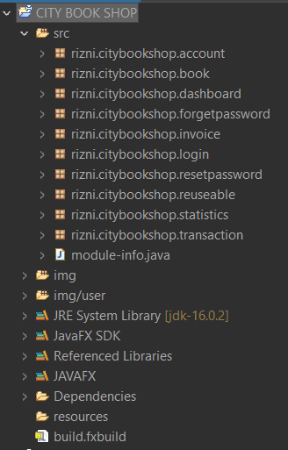

Figure 24 Module structure of the system

### 4.3. Reusable components

Reusable components are created inside the Rizni.citybookshop.reuseable package for reduce code repetition and enhance the system performance. Below figure is illustrate the reusable components.

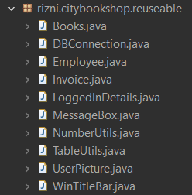

Figure 25 Reusable components

### 4.4. Object oriented programming

In this context, an object is a real-world item such as a pen or a chair or a table or a computer or a watch. In Object-Oriented Programming, classes and objects are used to create a program. Software development and maintenance are simplified by the following concepts: objects, classes, inheritance, encapsulation, polymorphism and abstraction.

#### 4.4.1. Object

Objects are instances of classes created with specific data. An object occupies some space in heap memory until its life time is over. Object can be two categories

1. Anonymous object

Anonymous objects don’t have any variable name to call it again. It doesn’t have stack memory allocation; it uses only heap memory for the allocation.

General syntax:

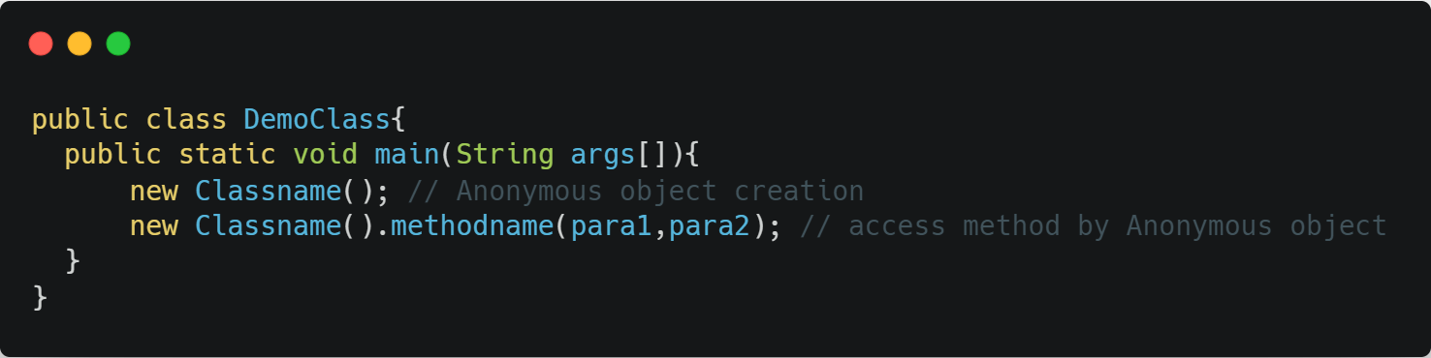

Figure 26 Anonymous object – general syntax

Used in the system:

Almost 90% of objects are created as anonymous object for utilize memory management. Because when particular task is finished then that object eligible for garbage collection (GC)

Example 1: there is a method rememberMe developed for remember the user’s username and password when they tick the remember me check box in the login page. It designed for increase the user experience. In that method to access database methods it is created as anonymous object. See figure 27 below

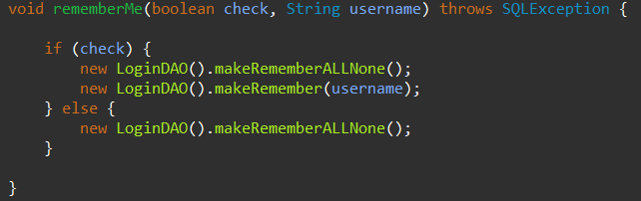

Figure 27 Anonymous object - example 1

Example 2: For showing the messages to the user, there is a class created for messageBox and that contain a method called showDialog. In the entire system to call that showDialog method for displaying a message; An anonymous object creation is used. See figure 28.



Figure 28 Anonymous object - example 2

Example 3: In statisticsController, for set data for charts anonymous object is created from Chart class inside initialize() method.

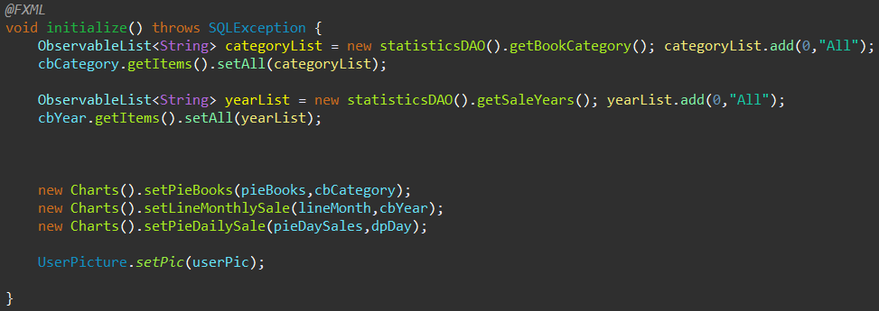

Figure 29 Anonymous object - example 3

1. Known object

Known objects can refer multiple times. It consumes heap memory for the object creation and also it creates stack memory by allocating a variable for it. So, by calling that variable name this kind of objects can recall anytime. Until the system is ending this kind of objects cannot be eligible for garbage collection (GC).

General syntax:

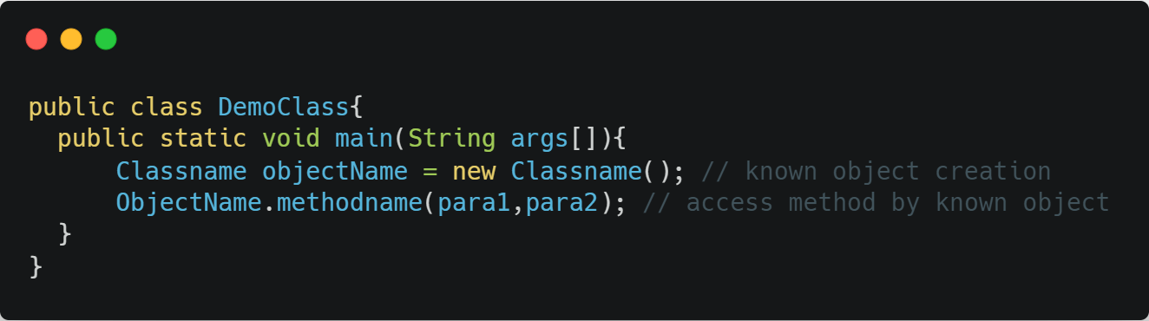

Figure 30 Known object - general syntax

Used in the system:

This kind of objects are mostly developed in query process in the database accessing objects. Because this kind of objects is useful for retrieve data from particular entity’s tuple and store it into the collection framework.

Example 1: Inside the while loop of getEmployeeDetails from AccountDAO Class, there is an object created as known object and assigned that into a name ‘e’. then assigned all the retrieved values from database to that object and added to an employee list namely ‘eList’.

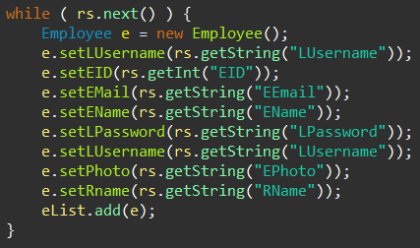

Figure 31 Known object - example 1

Example 2: Inside the while loop of getBooksDetails from BookDAO Class, there is an object created as known object and assigned that into a name ‘b’. then assigned all the retrieved values from database to that object and added to a book list namely ‘bList’.

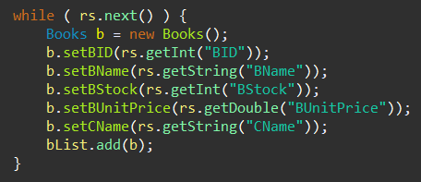

Figure 32 Known object - example 2

Example 3: Inside the while loop of getInvoiceDetails from InvoiceDAO Class, there is an object created as known object and assigned that into a name ‘i’. then assigned all the retrieved values from database to that object and added to an invoice list namely ‘iList’.

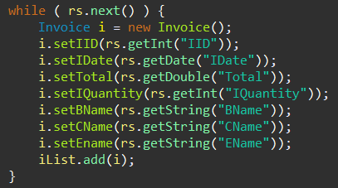

#### 4.4.2. Class

Alternatively, a class can serve as a blueprint from which an individual object can be created. Also, class doesn’t occupy any spaces in RAM. There are 3 types of classes are there.

1. Regular class

Regular classes are offer multiple object creation and inheritance

General syntax:

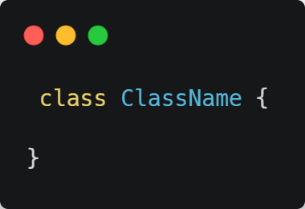

Figure 33 Regular class - General syntax

Used in the system:

All classes are created as regular class in this system

Example 1: Login class

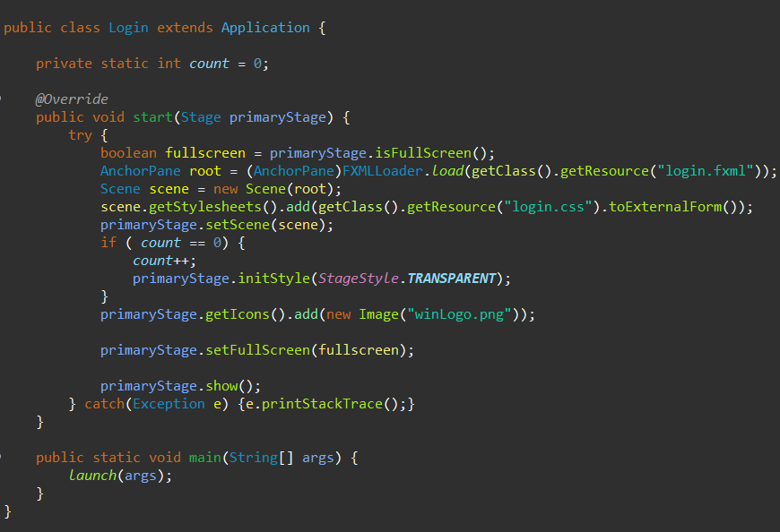

Figure 34 Login class – example 1

Example 2: DBConnection

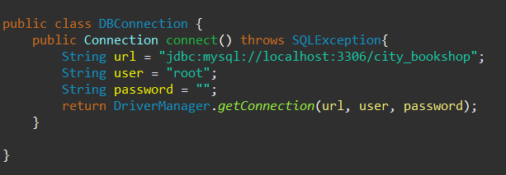

Figure 35 DBConnection - example 2

Example 3: dashboardController

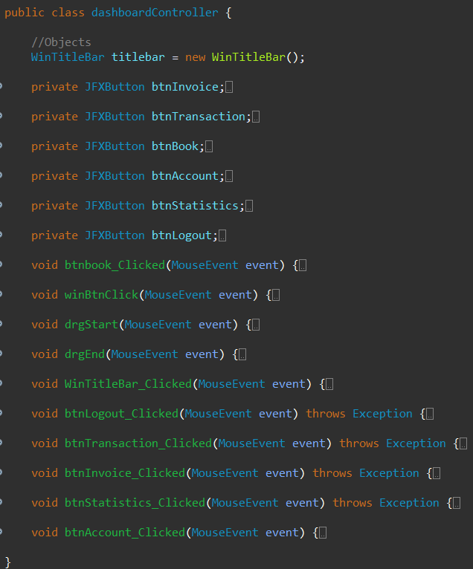

Figure 36 dashboardController - example 3

1. Inner class

When a class created inside a class, then that class is known as inner class

General syntax:

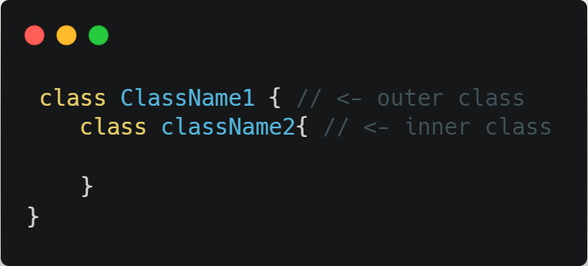

Figure 37 Inner class - general syntax

1. Anonymous class

Anonymous classes cannot call again because they don’t have a name. this kind of class are created for change implementation of the class to various situations. For implement this kind of class there is an already a abstract class need for it. In a simple word anonymous classes are used give implementation for abstract classes in different scenarios,

General Syntax:

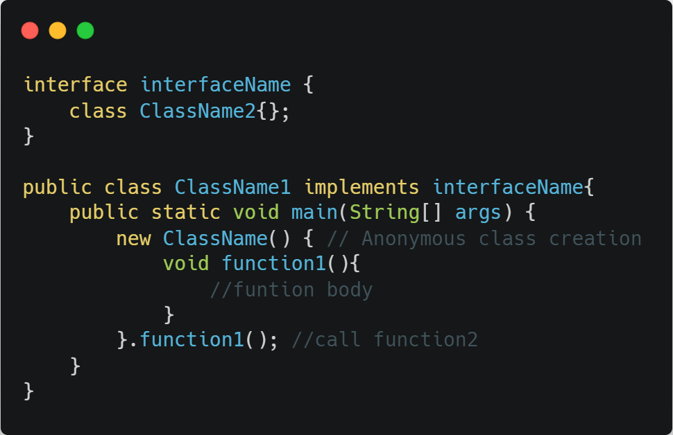

Figure 38 Anonymous class - general syntax

#### 4.4.3. Inheritance

Inheritance is a technique in Java that allows one object to inherit all of its parent object's attributes and actions. It is possible to build new Java classes that are based on existing ones. It is possible to reuse methods and properties from the parent class when you inherit from it.

(Inheritance in Java - Javatpoint, 2021)

There are mainly 4 types of inheritance are there:

1. Single level

Single level inheritance is, one class inherit another class. It means there will be one parent class and one child class.

General syntax:

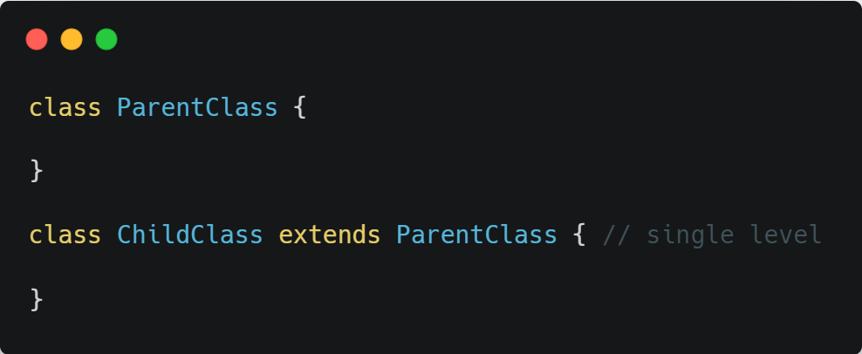

Figure 39 Single level inheritance - general syntax

Used in the system:

Example 1: In LoggedInDetails Class, LoggedInDetailsDAO class inheriting LoggedInDetails class at single level

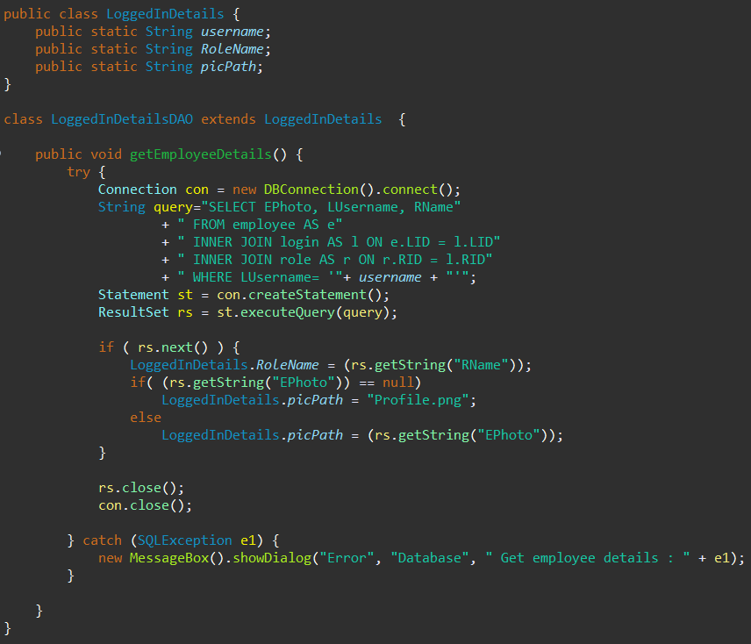

Figure 40 Single level inheritance - Example 1

Example 2: In Login class. Login class inheriting Application class at single level

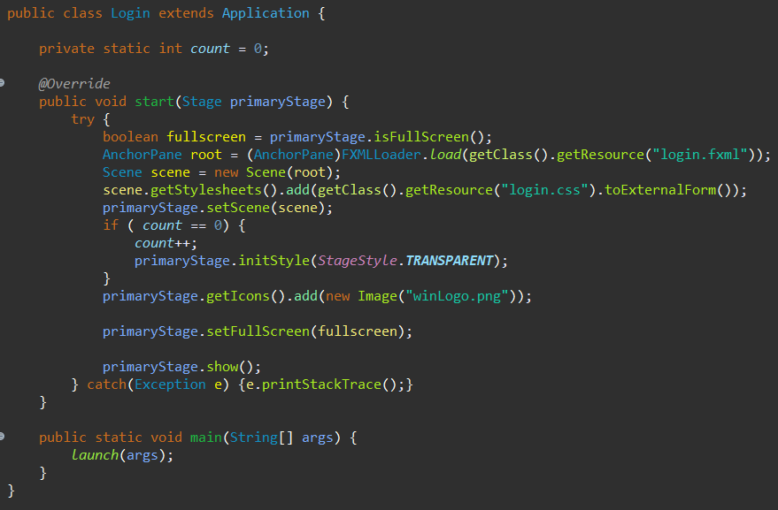

Figure 41 Single level inheritance - example 2

Example 3: In Invoice class, Invoice class inheriting Application at single level

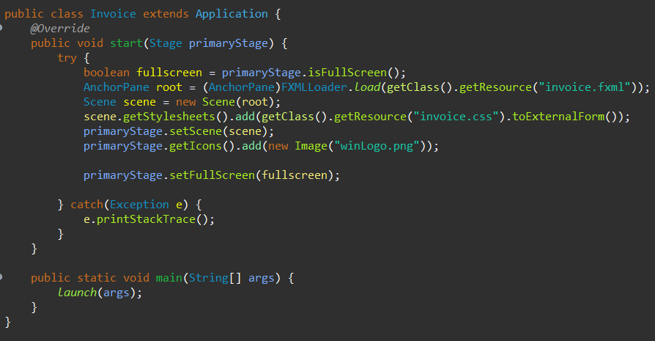

Figure 42 Single level Inheritance - example 3

1. Multi-level

Multi-level inheritance is, one class inherit another class and another class inherit the inherited class. It means there will be one grandparent class, one parent class and one child class

General syntax:

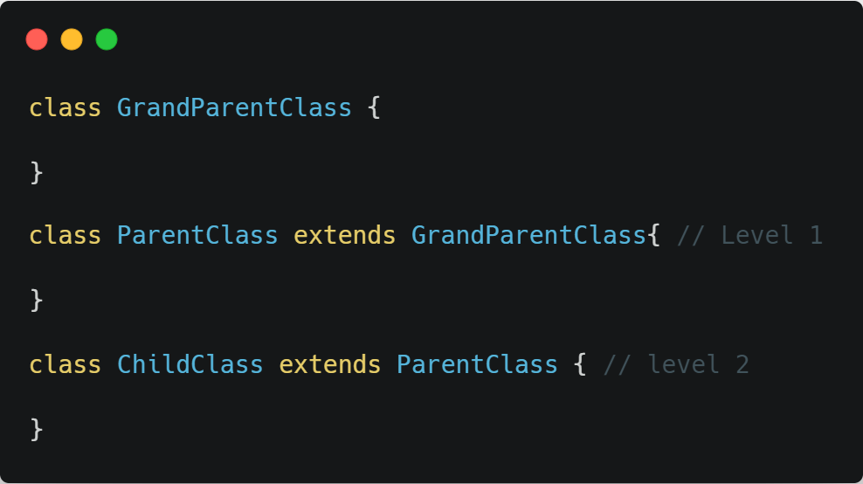

Figure 43 multi-level inheritance - general syntax

1. Hierarchical

Hierarchical inheritance means two classes inherits the same class

General syntax:

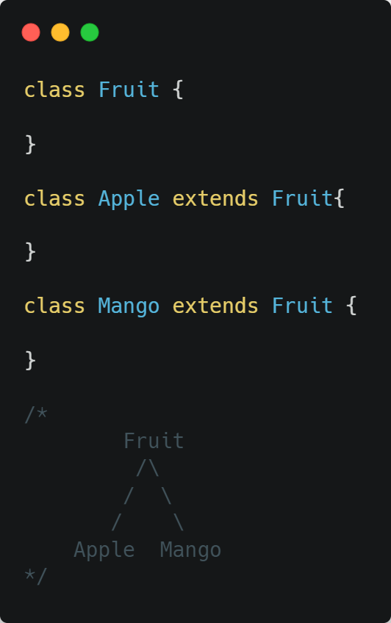

Figure 44 Hierarchical inheritance - general syntax

1. Multiple

Multiple inheritance means, a class inherits more than one class

General syntax;

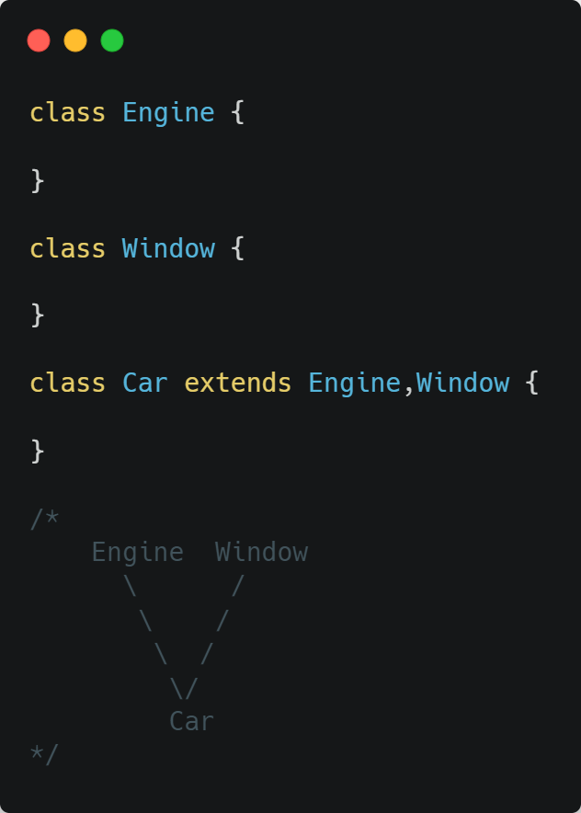

Figure 45 Multiple inherence - general syntax

#### 4.4.4. Encapsulation

Data (variables) and code (methods) are encapsulated in Java as a single entity. Classes that implement this technique can hide their variables and only provide access to them through the methods of their own class.

(Java - Encapsulation, 2021)

General syntax:

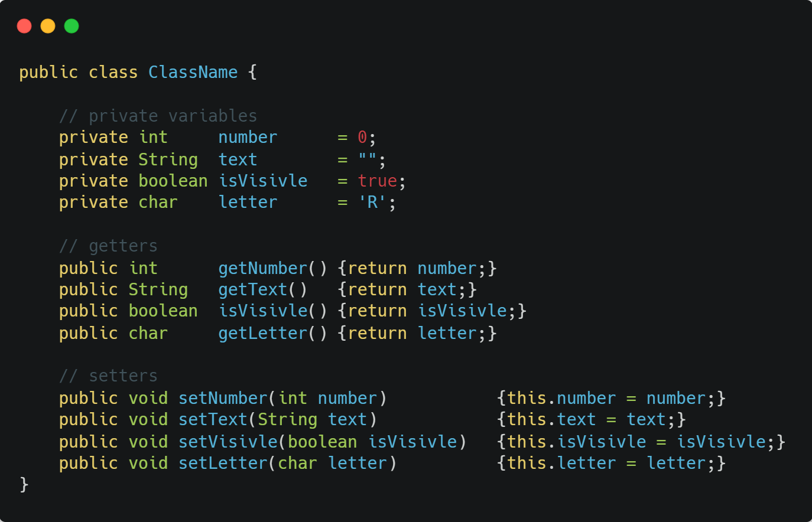

Figure 46 Encapsulation - general syntax

Used in the system:

Example 1: Book class

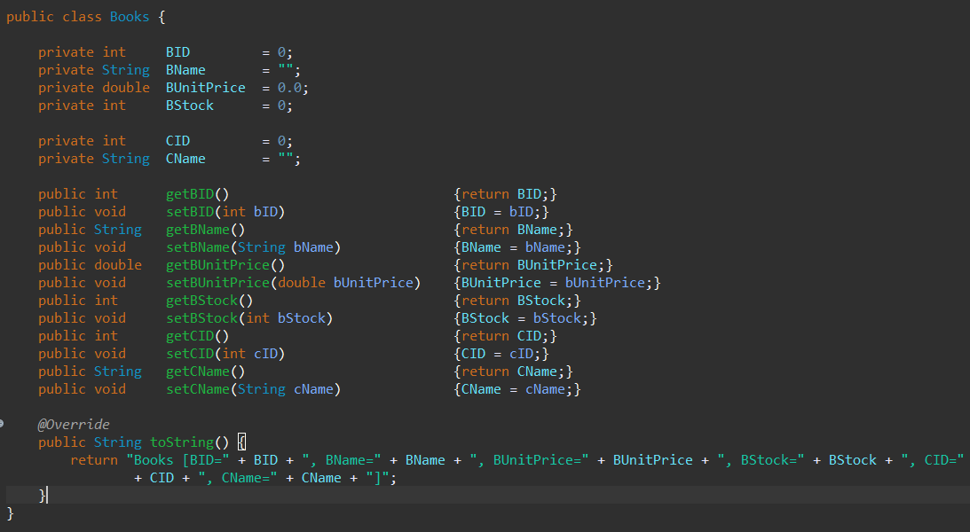

Figure 47 Encapsulation - example 1

Example 2: Employee class

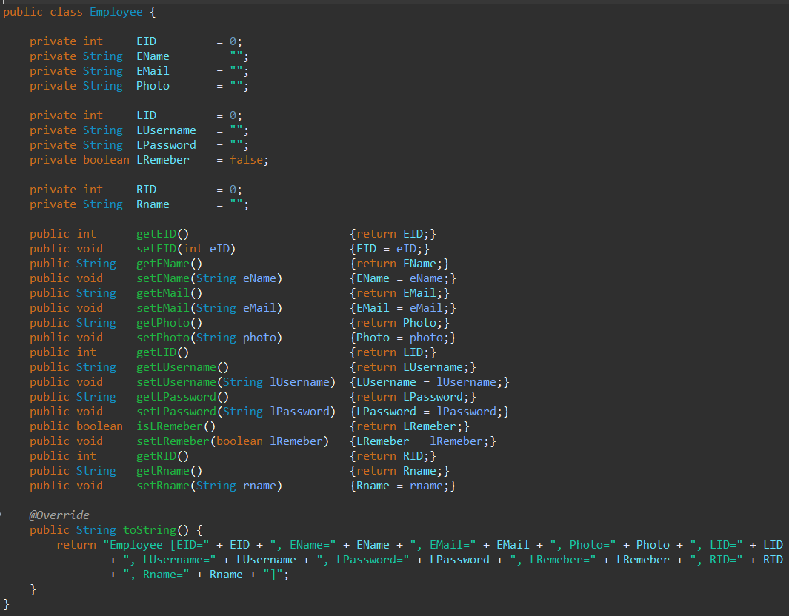

Figure 48 Encapsulation - example 2

Example 3:

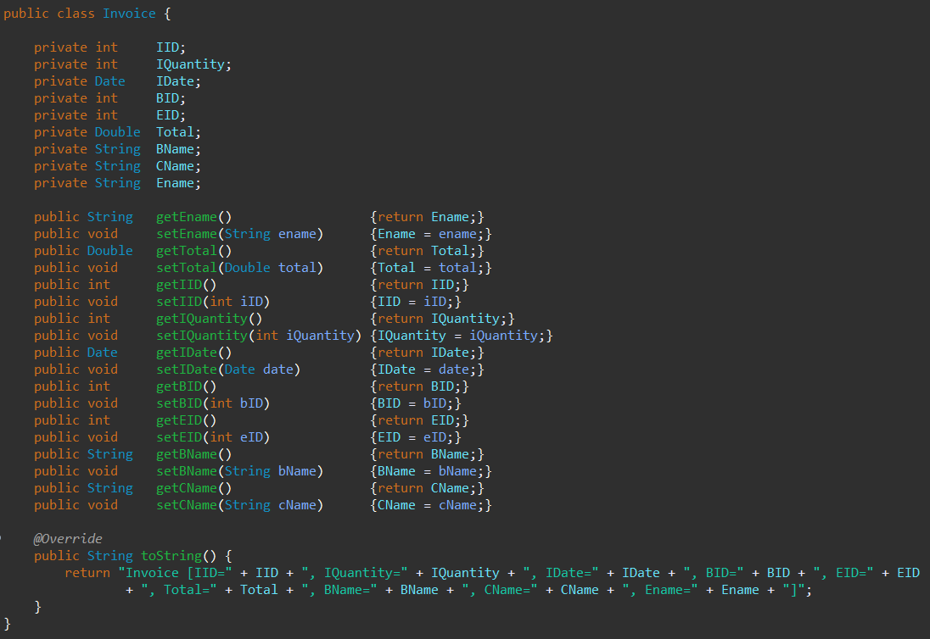

Figure 49 Encapsulation - example 3

#### 4.4.5. Polymorphism

In Java, polymorphism refers to an object's capacity to take on several forms. To put it another way, polymorphism in Java enables us to accomplish the same operation in a variety of ways.

(Polymorphism in Java and Java Polymorphism Examples, 2021)

##### 4.4.5.1. Method overloading

Method overloading is a Java feature that allows us to define many methods with the same name in the same class, each of which performs differently. The term Overloaded Methods refers to methods that have more than one instance of the same name in the same class.

General syntax:

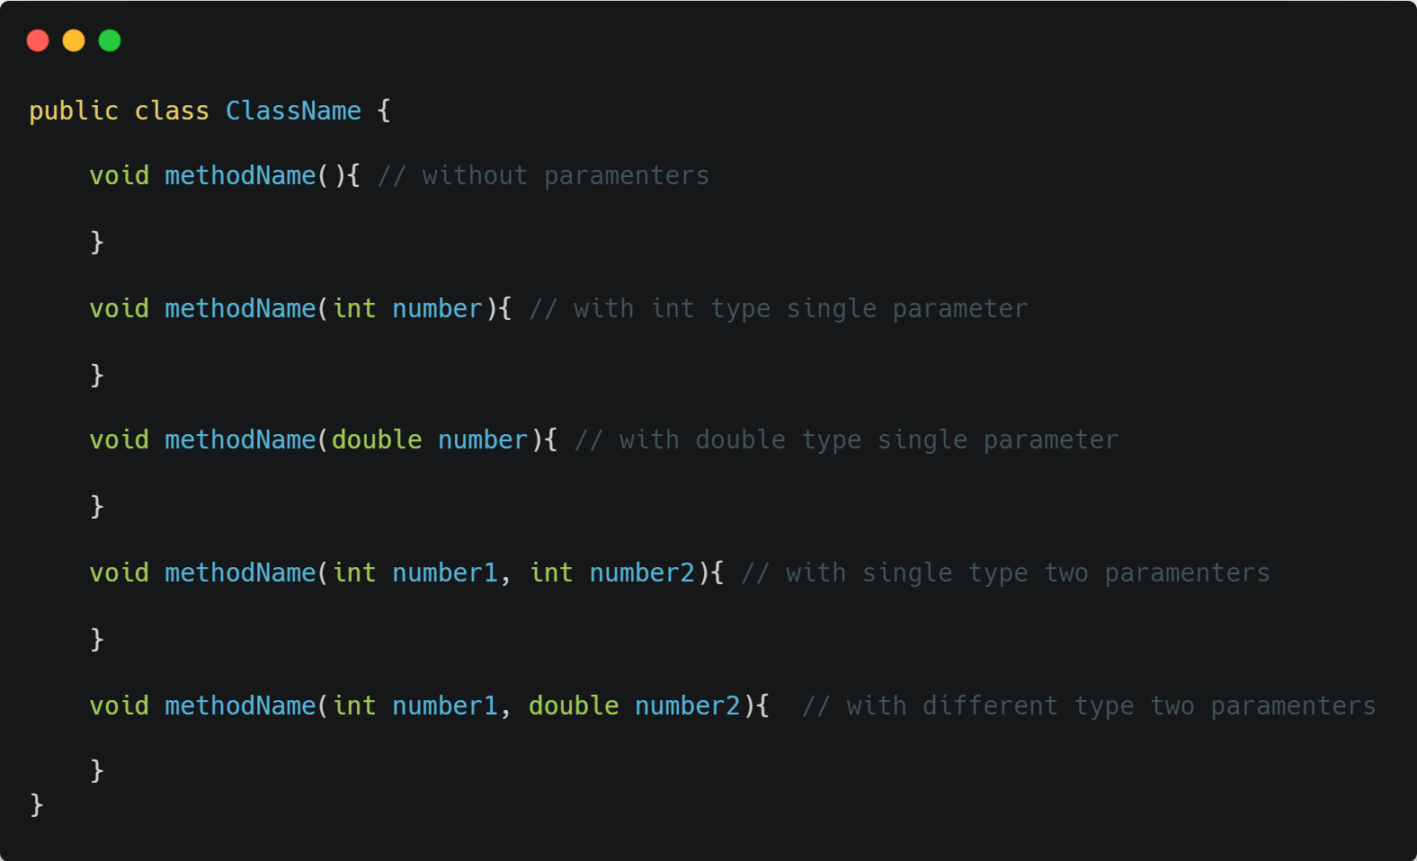

Figure 50 Method overloading - general syntax

Used in the system:

Example 1: In BookDAO class, deleteBook method overloaded with different type single parameter

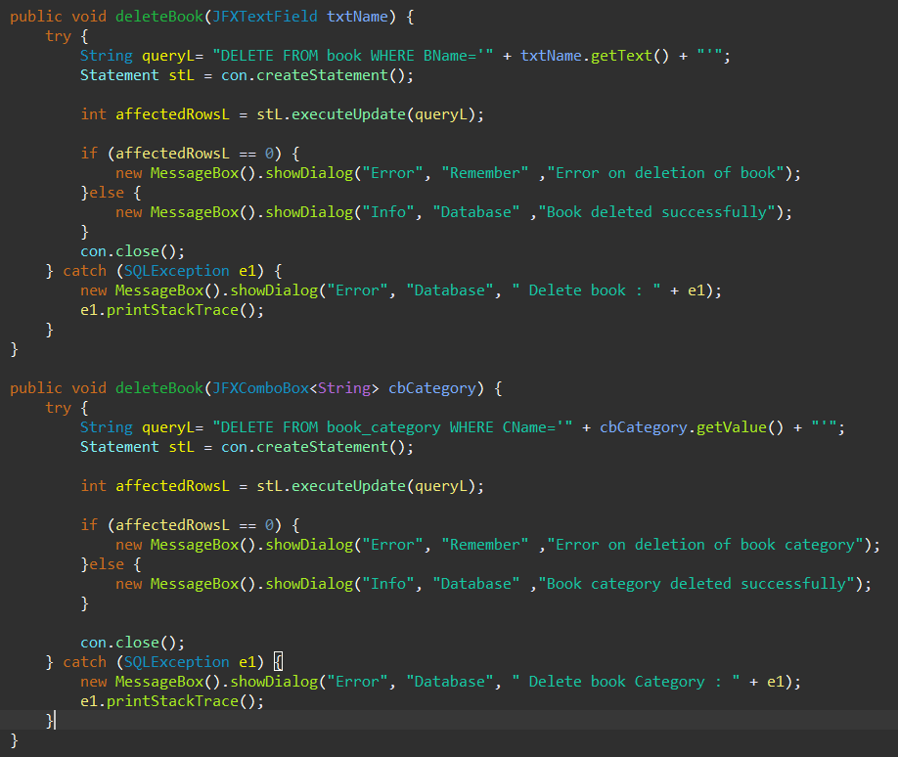

Figure 51 Method overloading - example 1

Example 2: in Invoice validation class, verify method overloaded by multiple parameters varies.

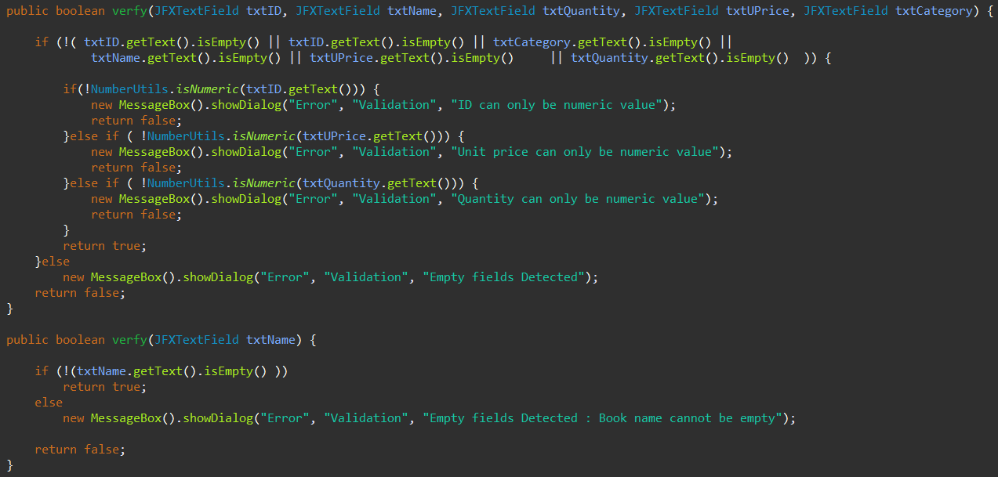

Figure 52 Method overloading - example 2

##### 4.4.5.2. Method overriding

Overriding is a feature that allows a subclass or child class to offer a customized implementation of a method that is already available from one of its super-classes or parent classes. Subclasses are said to override super-classes when a method in a subclass has the same parameters, same name, or same signature, and also, same return type as a method in its superclass.

(Overriding in Java - GeeksforGeeks, 2021)

General syntax:

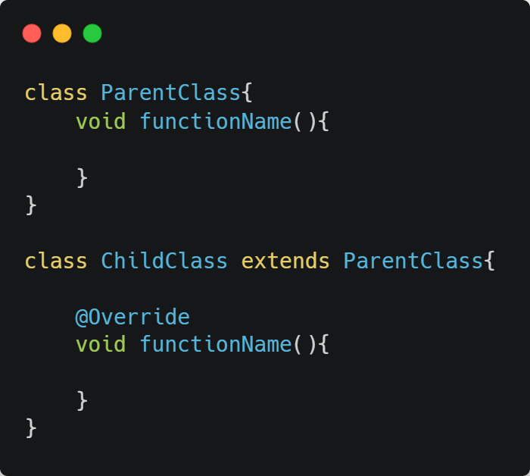

Figure 53 Method overriding - General syntax

Used in the system:

Example 1: Account class overriding start class from Application class

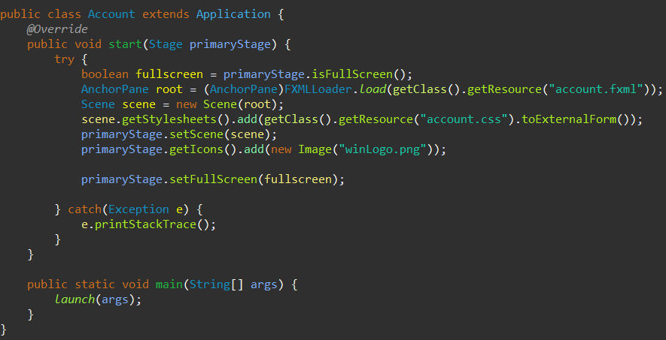

Figure 54 Method overriding - example 1

Example 2: RestPassword class overriding start class from Application class

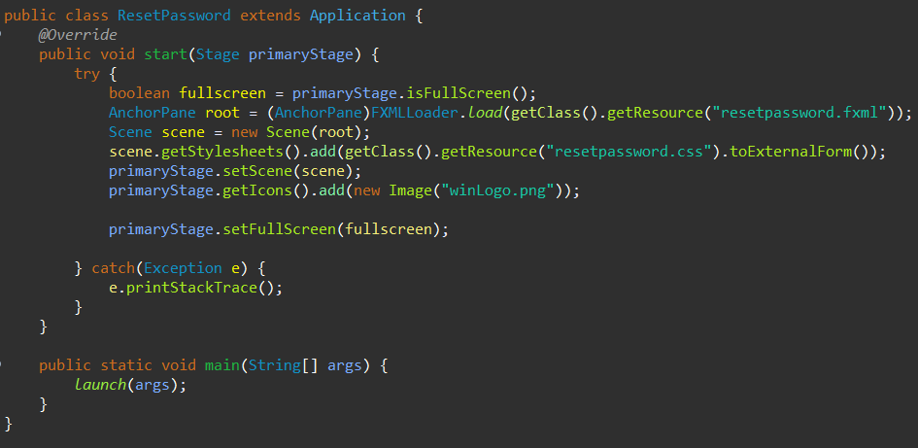

Figure 55 Method overriding - example 2

Example 3: Statistics class overriding start class from Application class

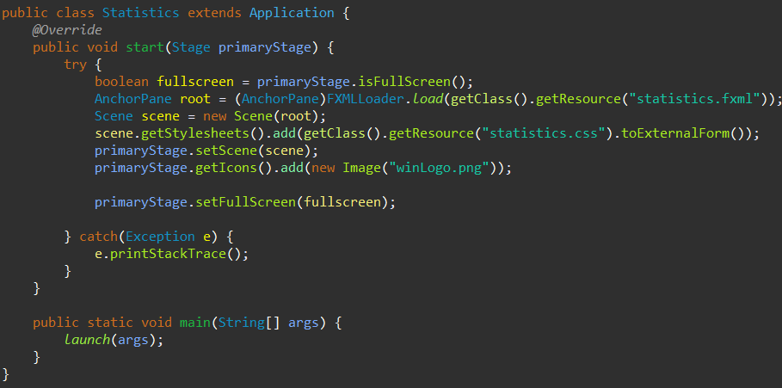

Figure 56 Method overriding - example 3

#### 4.4.6. Abstraction

Abstraction is the technique of concealing some facts from the user and only giving them what they need to know. It is possible to create abstraction by using abstract classes or interfaces

(Java Abstraction, 2021)

General syntax:

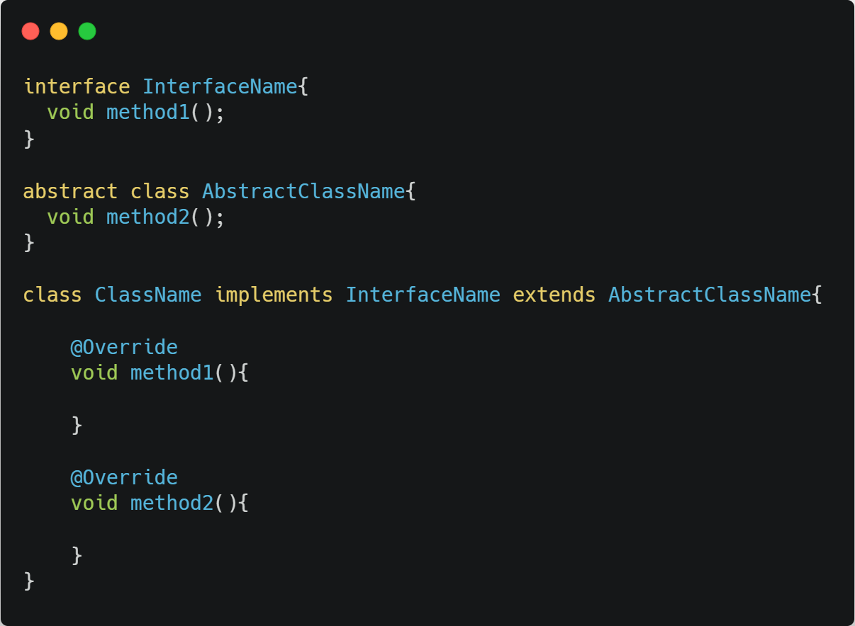

Figure 57 Abstraction - General syntaxe

Used in the system:

Example 1: Application class

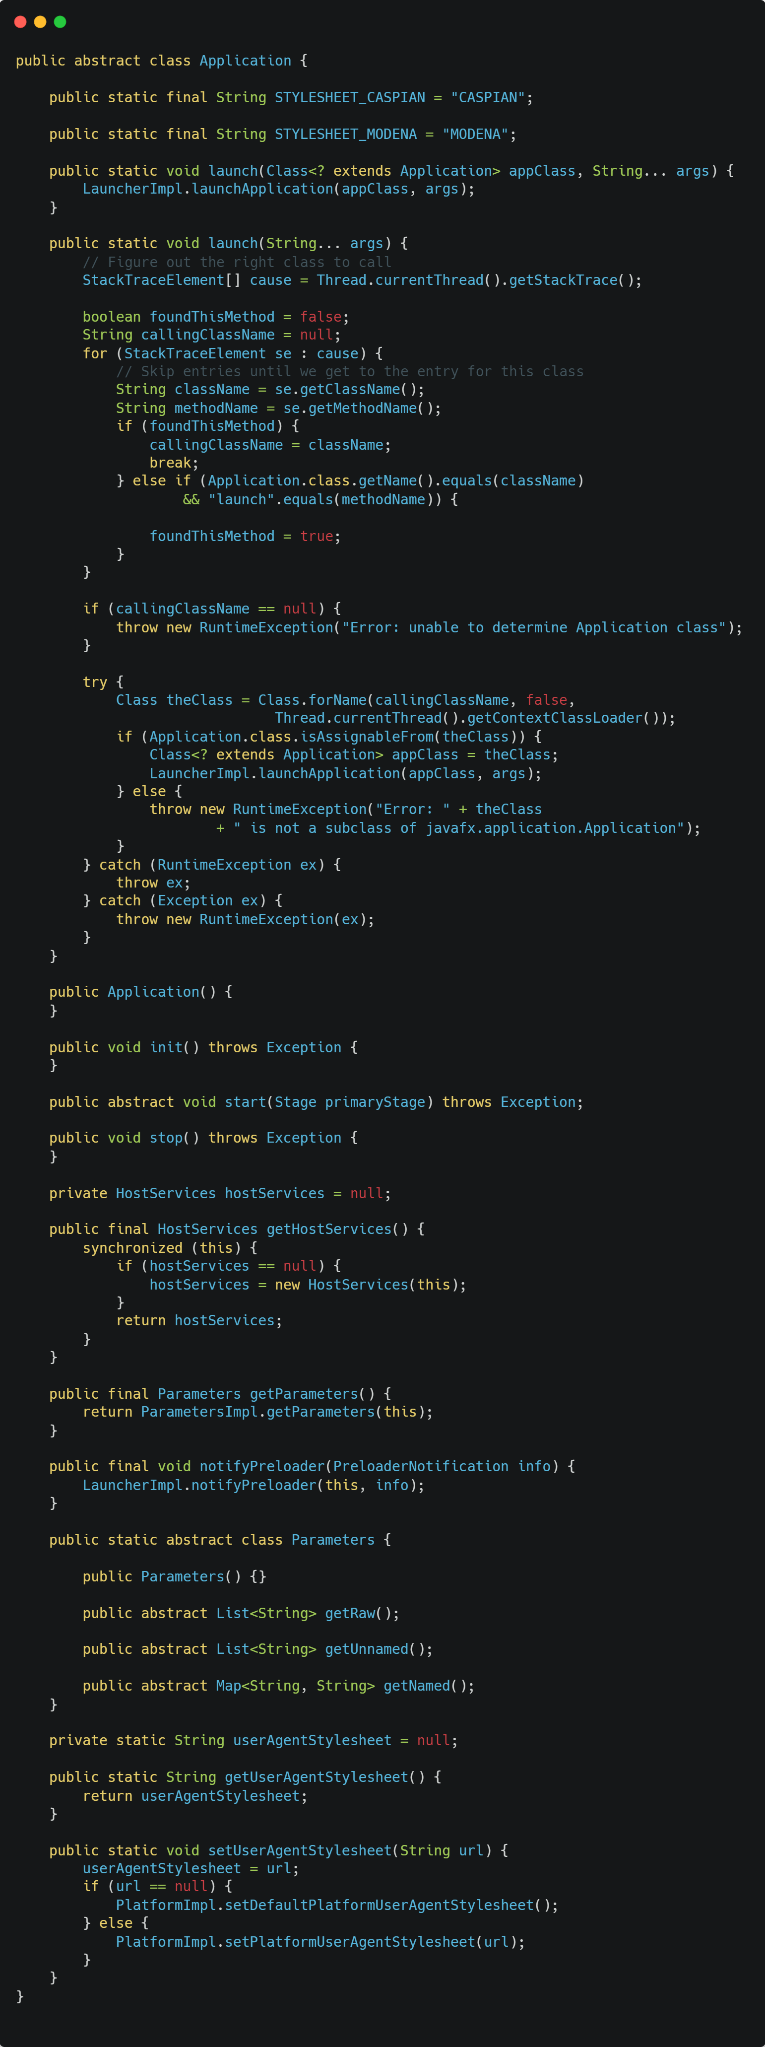

Figure 58 Abstraction - example 1

## 5. User manual

### 5.1. Prerequisites

To run this application there are two basic requirements are there. The entire system developed based on JavaFX. So, JavaFX SDK is need to start the application. Like vise the system used citybook_shop database which created in MySQL database software for data management. Due that MySQL database software and citybook_shop database is needed

Steps for the install prerequisites:

* JavaFX SDK V16

1. Click <https://gluonhq.com/download/javafx-16-sdk-windows/> this links to download JavaFX SDK V16.
2. Go to download location and extract the file to C drive.
3. In Windows 10, type in start search bar as “Edit the system environment variables” and click it.
4. 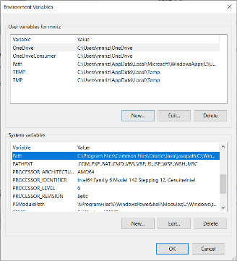Search path in system variable list and click to edit

Figure 59 Environment variables

1. 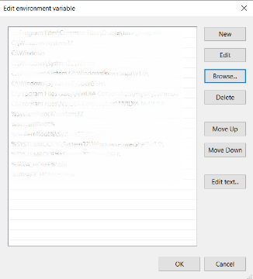Click browse and direct to “c:\ \javafx-sdk-16 \bin” and click ok then click ok and then click

Figure 60 Edit environment variables

* MySQL

1. Click <https://sourceforge.net/projects/wampserver/files/latest/download> this links to download WAMP Server
2. After download, click the setup.exe and run it
3. Click next to all in the setup wizard but in one place there will be option selection will be display. In that moment select PHP last version and MySQL last version. And install it
4. After installation click the WAMP server and run it
5. Open a web browser and type 127.0.0.1. in the URL bar
6. Click phpMyAdmin
7. Type root for username and give blank for password. Select MySql in database selection
8. Click Go

* citybook_shop

1. Login in PhpMyAdmin with MySQL
2. Click import tab
3. Click choose file
4. Browse to city book shop installation folder and go to database folder and select citybook_shop.sql
5. Click Go

### 5.2. Login page

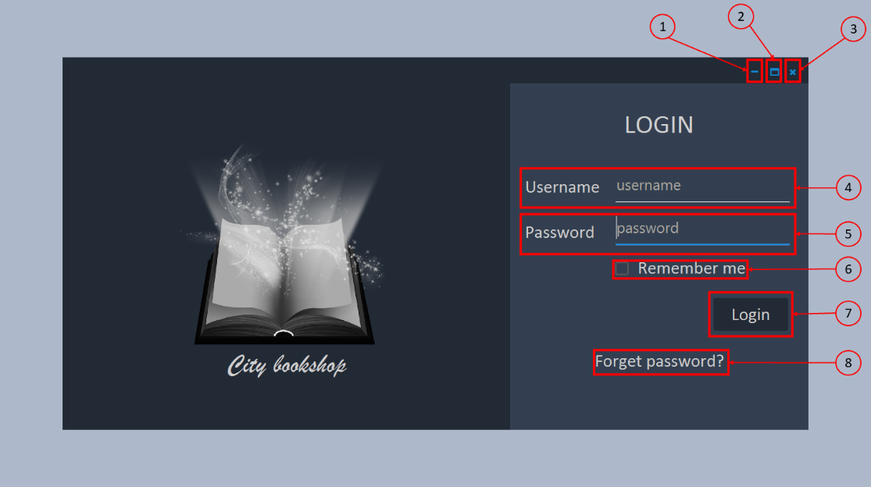

Figure 61 Login page

Login page is the first page when the application is start to run. In this page use need to enter correct username and password or else there will be error message will be thrown via a message box. There are two optional programs namely Remember me and Forget password for remember the user’s login details for next login and reset the password when user forget their password respectively.

Components of Login page

1. Minimize – Minimize the application
2. Maximize – Maximize the application
3. Close – Close the application
4. Username – Enter correct username
5. Password – Enter correct password
6. Remember me – When you click this system will remember your login details. So, in next login you don’t need to enter username and password.
7. Login – Click this button for login in
8. Forget password – Click this when you forget your password. It will direct you to forget password page

Events of Login page

1. Username field or password field is empty – Error Message: Empty fields detected
2. Username is wrong – Error message: Username is wrong
3. Username is Correct but password is wrong – Error message: Wrong password
4. Username and password are correct – Open Dashboard page

### 5.3. Forget password page

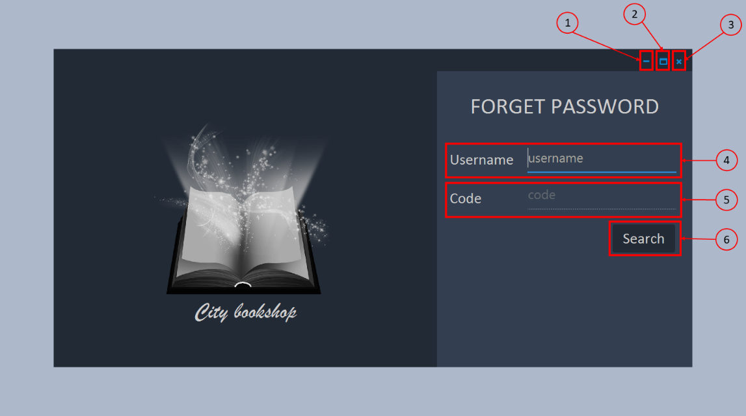

Figure 62 Forget password page

The motive of this page is to verify the user. First user needs to enter username in the username field and click search button. Then system will check whether username is correct or not. When username is correct then a verification code will send to a email address which they entered in to the system. Then user need to enter the verification code in filed as same as they got via mail. If that code is matched then it will direct them into reset password page

Components of Forget password page

1. Minimize – Minimize the application
2. Maximize – Maximize the application
3. Close – Close the application
4. Username – Enter correct username and click search
5. Code – Enter the verification code that you get from your email address
6. Submit (Search will change into submit) – Click submit, it will direct you to the reset password page

Events of Forget password page

1. Username field or Code field is empty – Error message: Empty fields detected
2. Username is wrong – Error message: Invalid username
3. Code is wrong – Error message: Invalid code
4. Code is Correct – Direct to reset password page

### 5.4. Reset password page

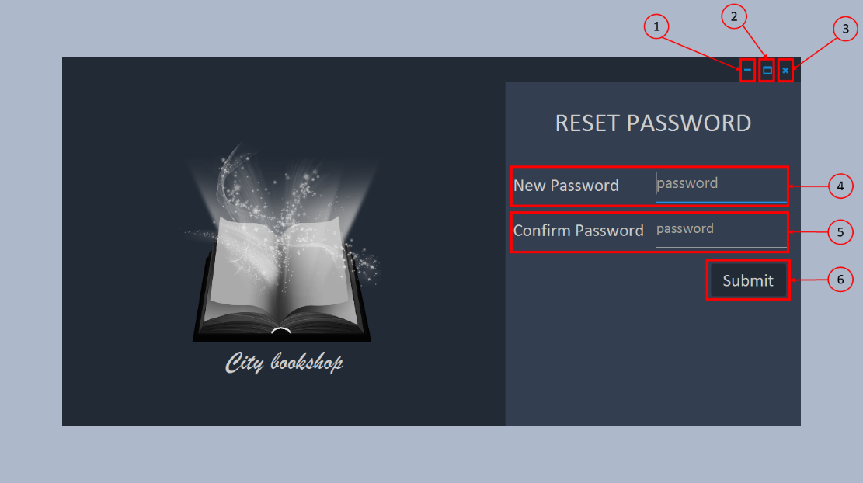

Figure 63 Reset password page

The motive of reset password page is to set new password for user account which verified from forget password page. User need to enter a password in the new password field and also, they need to enter same password in confirm password. This reduces the mistype passwords. Finally, when user click the submit button then it set the new password to that user account and direct them to dashboard page

Components of reset password page

1. Minimize – Minimize the application
2. Maximize – Maximize the application
3. Close – Close the application
4. New password – Enter your new password
5. Confirm password – Re-enter your new password
6. Submit – Click submit. It will set the new password and direct you to the dashboard window

Events of reset password page

1. New password field or confirm password is empty - Error message: Empty fields detected
2. New password and confirm password are matched – Set new password and direct to dashboard

### 5.5. Dashboard page

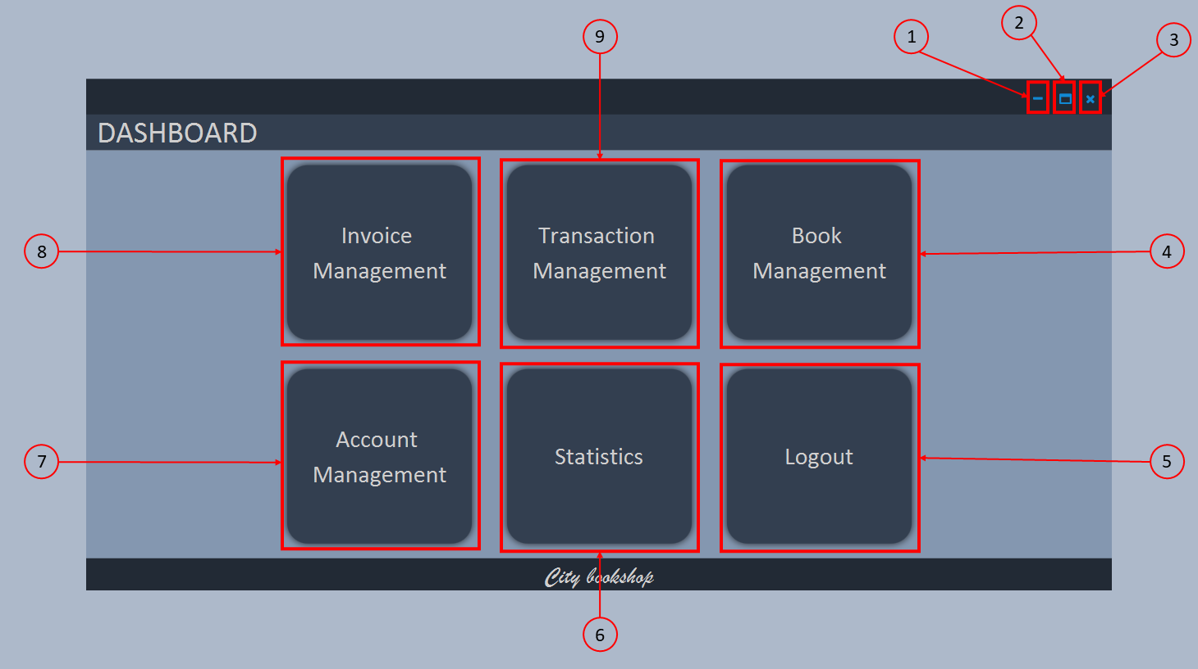

Figure 64 Dashboard page

The motive of dashboard page is to direct the user to their destination by displaying all the available tasks

Components of reset password page

1. Minimize – Minimize the application
2. Maximize – Maximize the application
3. Close – Close the application
4. Book management – direct the user to book management page
5. Logout – direct the user to login page
6. Statistics – direct the user to statistics page
7. Account management – Direct the user to account management page
8. Invoice management – Direct the user to invoice management page
9. Transaction management – Direct the user to transaction management page

Event of reset password page

1. Direct the user to their destination

### 5.6. Invoice management page

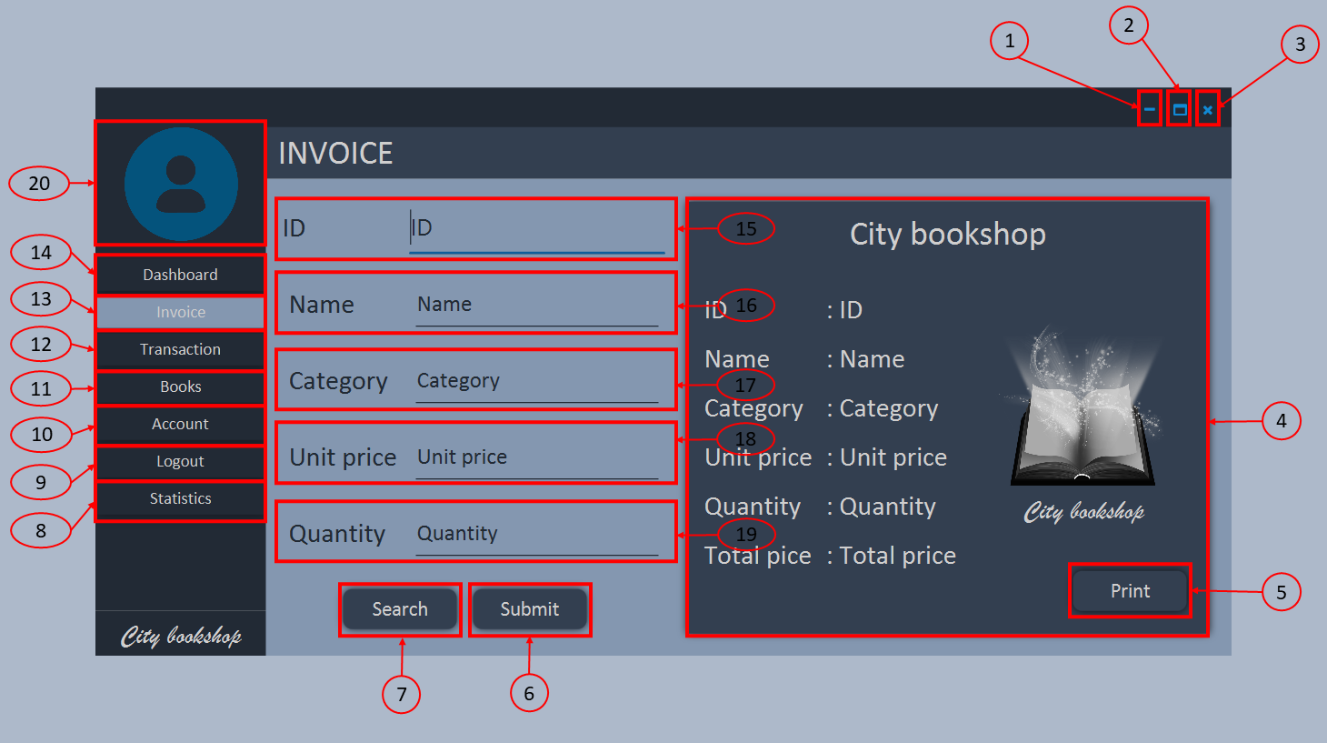

Figure 65 Invoice management page

The motive of the page is creating invoices. User need to give ID and quantity themselves. The book details can get by give a name of the book in the book field and click search button. It automatically fills the category and unit price; user don’t need to enter full name of the book in book field; they can get the book name by enter the book’s starting word and click search button. And also, there is side panel in left for navigation to other pages as in dashboard page

Components of invoice management page

1. Minimize – Minimize the application
2. Maximize – Maximize the application
3. Close – Close the application
4. Invoice sheet – Printable area for invoice receipt
5. Print – Print the invoice receipt
6. Submit – Create invoice and prepare invoice receipt
7. Search – Search a book
8. Statistics – direct the user to statistics page
9. Logout – direct the user to login page
10. Account management – Direct the user to account management page
11. Book management – direct the user to book management page
12. Transaction management – Direct the user to transaction management page
13. Invoice management – Direct the user to invoice management page
14. Dashboard – Direct the user to dashboard page
15. ID – Enter Invoice ID
16. Name – Enter book’s name
17. Category – Enter book’s category
18. Unit price – Enter book’s unit price
19. Quantity – Enter quantity of books
20. User picture – Displays user’s picture

Events of invoice management page

1. Direct the user to their destination
2. Search book
3. Create invoice
4. Prepare invoice receipt
5. Print invoice receipt
6. Display user’s picture

### 5.7. Transaction management page

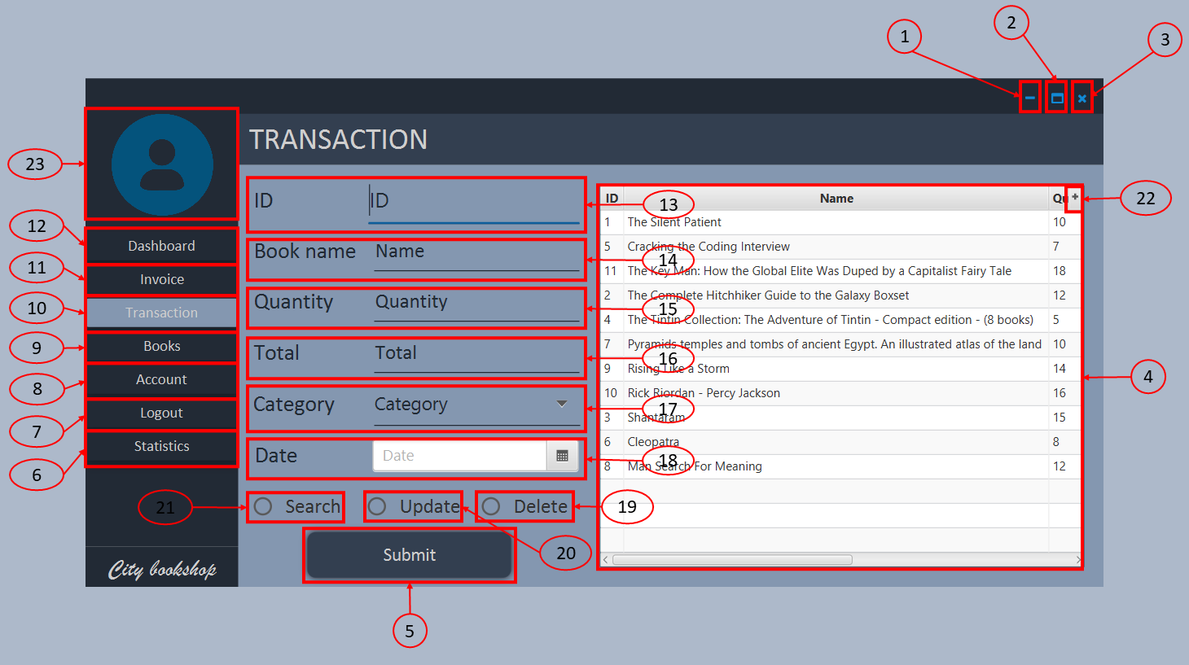

Figure 66 Transaction management page

The motive of transaction management page is to monitoring and alternate the invoice details. When user arrive to the transaction management page initially all invoice details will appear in the table. When user select a row then that row’s consecutive details automatically set to their text fields. Cashier can search an invoice. But admin can update, delete and search an invoice. And also, there is side panel in left for navigation to other pages as in dashboard page

Components of transaction management page

1. Minimize – Minimize the application
2. Maximize – Maximize the application
3. Close – Close the application
4. Invoice table – Show all invoice details
5. Submit – Execute the task
6. Statistics – direct the user to statistics page
7. Logout – direct the user to login page
8. Account management – Direct the user to account management page
9. Book management – direct the user to book management page
10. Transaction management – Direct the user to transaction management page
11. Invoice management – Direct the user to invoice management page
12. Dashboard – Direct the user to dashboard page
13. ID – Enter Invoice ID
14. Book name – Enter book’s name
15. Quantity – Enter quantity of books
16. Total – Total price of payment
17. Category – Enter book’s category
18. Date – Invoice created date
19. Delete – Option for delete an invoice
20. Update – Option for update an invoice
21. Search – option for search an invoice
22. Table optional button – Customize the displaying table
23. User picture – Displays user’s picture

Events of transaction management page

1. View all transaction
2. Search an invoice
3. Delete an invoice
4. Update an invoice
5. Customize table view details
6. Direct the user to their destination
7. Display user’s picture

### 5.8. Book management page

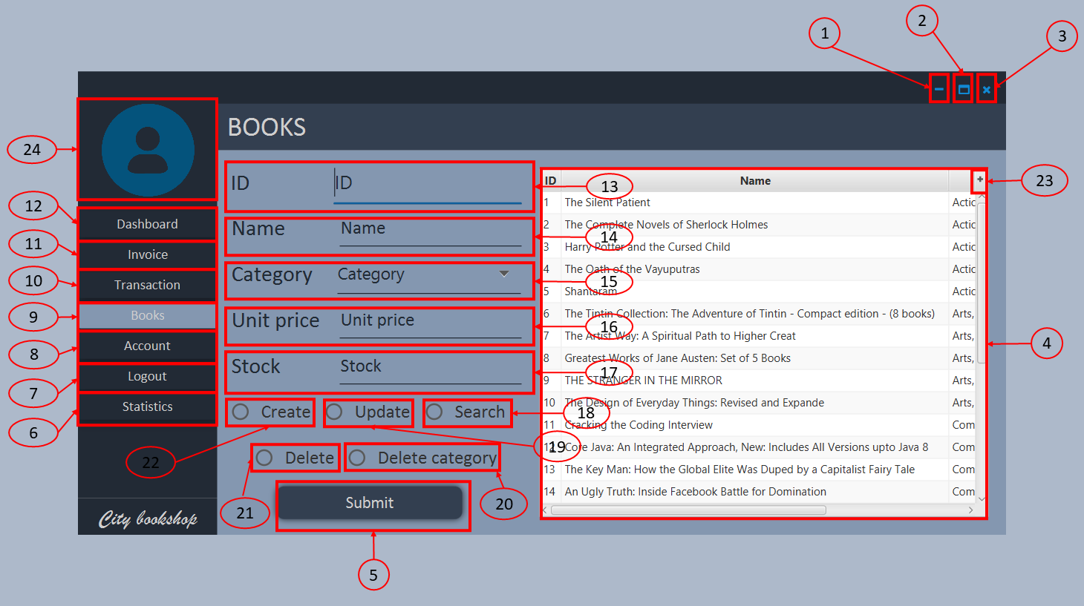

Figure 67 Book management page

The motive of book management page is to monitoring, create and alternate the book details. When user arrive to the book management page initially all book details will appear in the table. When user select a row then that row’s consecutive details automatically set to their text fields. Cashier can search, create and update the books. But admin can delete the category, delete the books, search, create and update the books. And also, there is side panel in left for navigation to other pages as in dashboard page

Components of book management page

1. Minimize – Minimize the application
2. Maximize – Maximize the application
3. Close – Close the application
4. book table – Show all book details
5. Submit – Execute the task
6. Statistics – direct the user to statistics page
7. Logout – direct the user to login page
8. Account management – Direct the user to account management page
9. Book management – direct the user to book management page
10. Transaction management – Direct the user to transaction management page
11. Invoice management – Direct the user to invoice management page
12. Dashboard – Direct the user to dashboard page
13. ID – Enter book ID
14. Book name – Enter book’s name
15. Category – Enter book’s category
16. Unit price – Enter unit price of the book
17. Stock – Enter books stock count
18. Search – option for search a book
19. Update – Option for update a book
20. Delete category – Option for delete book category
21. Delete – Option for delete a book
22. Create – option for create a book
23. Table optional button – Customize the displaying table
24. User picture – Displays user’s picture

Events of book management page

1. View all books
2. Search a book
3. Delete a book
4. Delete a book category
5. Create a book
6. Update a book
7. Customize table view details
8. Direct the user to their destination
9. Display user’s picture

### 5.9. Account management page

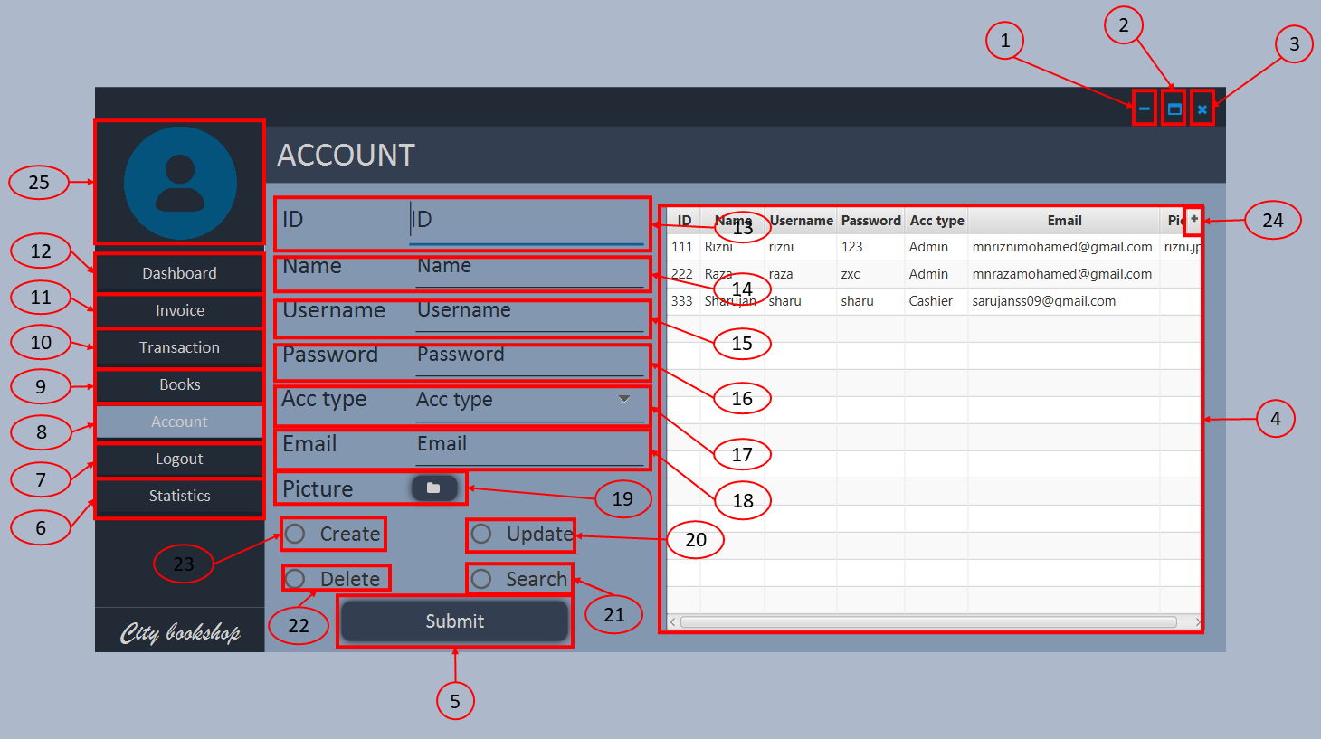

Figure 68 Account management page

The motive of account management page is to monitoring, create and alternate the accounts. When cashier arrive to the account management page initially. their account details will appear in the table. But when admin arrives, initially all account details will appear in the table. When user select a row then that row’s consecutive details automatically set to their text fields. Cashier can only update their account. But admin can delete, update, search and create any account. And also, there is side panel in left for navigation to other pages as in dashboard page

Components of account management page

1. Minimize – Minimize the application
2. Maximize – Maximize the application
3. Close – Close the application
4. Account table – Show all account details
5. Submit – Execute the task
6. Statistics – direct the user to statistics page
7. Logout – direct the user to login page
8. Account management – Direct the user to account management page
9. Book management – direct the user to book management page
10. Transaction management – Direct the user to transaction management page
11. Invoice management – Direct the user to invoice management page
12. Dashboard – Direct the user to dashboard page
13. ID – Enter account ID
14. Account name – Enter account name
15. Username – Enter username for their account
16. Password – Enter password for their account
17. Email – Enter email address for forget password process
18. Picture – Select picture for account picture
19. Update – Option for update an account
20. Search – option for search an account
21. Delete – Option for delete an account
22. Create – option for create an account
23. Table optional button – Customize the displaying table
24. User picture – Displays user’s picture

Events of account management page

1. View account/s
2. Search an account
3. Delete an account
4. Create an account
5. Update an account
6. Customize table view details
7. Direct the user to their destination
8. Display user’s picture

### 5.10. Statistics page

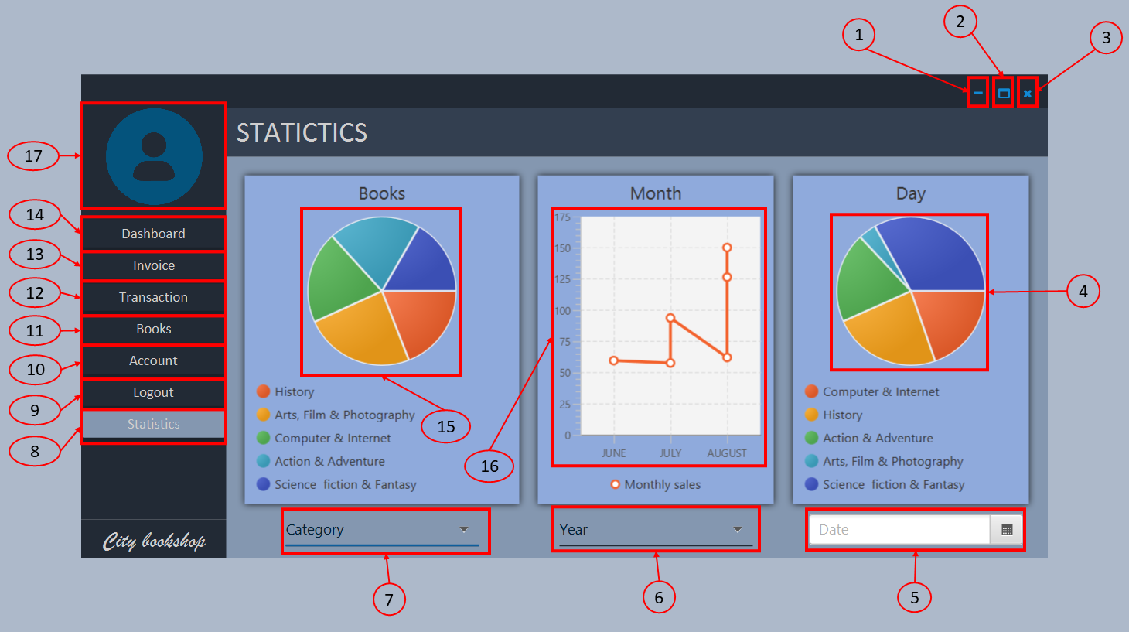

Figure 69 Statistics page

The motive of statistics page is to monitoring book inventory and sales progress. There are three sections inside this page. Those are book inventory unit which displays in pic chart, Monthly sales of year which displays in a line a chart and daily sales which displays in a pie chart, when user arrives, initially, the available number of total books in each category will display in the book’s pie chart; the number total sales in each month of current year will display in the month line chart; the number of sales going on a day in each book category will display in a day’s pie chart. By selecting categories under the book’s pie chart user can view available books and its quantity of a category. By selecting year under the month’s line chart user can view total sales of each month of particular year. By pic a date under day’s pie chart user can view what are the books sold in that particular day with total prices. There is side panel in left for navigation to other pages as in dashboard page

Components of statistics page

1. Minimize – Minimize the application
2. Maximize – Maximize the application
3. Close – Close the application
4. Day pie chart – Click to refresh the data
5. Date picker – Pic a particular date for view sales of particular day
6. Year – Select a year for view sales of each month in a particular year
7. Category – Select a category for view books availability of particular category
8. Statistics – direct the user to statistics page
9. Logout – direct the user to login page
10. Account management – Direct the user to account management page
11. Book management – direct the user to book management page
12. Transaction management – Direct the user to transaction management page
13. Invoice management – Direct the user to invoice management page
14. Dashboard – Direct the user to dashboard page
15. Book pie chart – Click to refresh the data
16. Month line chart – Click to refresh the data
17. User picture – Displays user’s picture

Events of statistics page

1. View available quantities of each category
2. View available quantities of each book
3. View monthly sales of each month
4. View daily sales
5. Get most profitable month of a year
6. Get most profitable book
7. Direct the user to their destination
8. Display user’s picture

## 6.Test summery report



Figure 70 Test summery report

## 7. Future recommendation

* In statistics page, highlight the sales made on day in the date picker of daily sales
* Make compatible continue compatible in maximize window
* Create new job roles with new permission areas
* Send verification codes to mobile phones
* Convert this application to cloud based system for remote access
* Enhance print view
* Convert possible validation process to database by using CHECK statement
* Make inter modularity between all packages for create security, privacy and reduce repeated codes

# Gantt chart

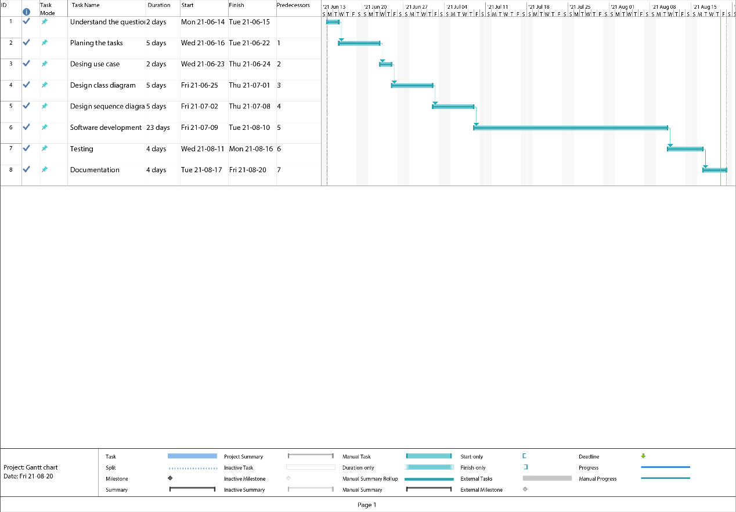

Figure 71 Gantt chart

# Plagiarism report

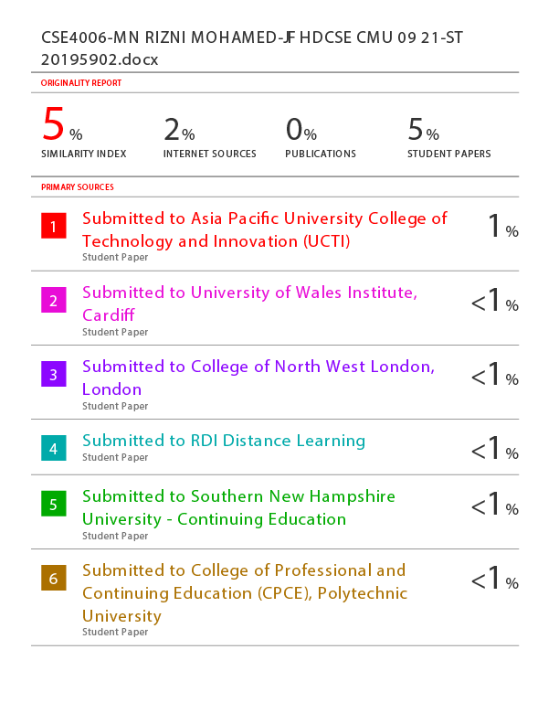

Figure 72 Plagiarism report - page 1



Figure 73 Plagiarism report - page 2



Figure 74 Plagiarism report - page 3



Figure 75 Plagiarism report - page 4

# Reference

* Tutorialspoint.com. 2021. SDLC - Overview. [online] Available at: <https://www.tutorialspoint.com/sdlc/sdlc_overview.htm> [Accessed 17 August 2021].
* www.javatpoint.com. 2021. UML Use Case Diagram - Javatpoint. [online] Available at: <https://www.javatpoint.com/uml-use-case-diagram> [Accessed 17 August 2021].
* GeeksforGeeks. 2021. Unified Modeling Language (UML) | Sequence Diagrams - GeeksforGeeks. [online] Available at: <https://www.geeksforgeeks.org/unified-modeling-language-uml-sequence-diagrams/> [Accessed 17 August 2021].
* Tutorialspoint.com. 2021. SDLC - Overview. [online] Available at: <https://www.tutorialspoint.com/sdlc/sdlc_overview.htm> [Accessed 18 August 2021].
* GeeksforGeeks. 2021. Overriding in Java - GeeksforGeeks. [online] Available at: <https://www.geeksforgeeks.org/overriding-in-java/> [Accessed 18 August 2021].
* GreatLearning Blog: Free Resources what Matters to shape your Career!. 2021. Polymorphism in Java and Java Polymorphism Examples. [online] Available at: <https://www.mygreatlearning.com/blog/polymorphism-in-java/> [Accessed 18 August 2021].
* Tutorialspoint.com. 2021. Java - Encapsulation. [online] Available at: <https://www.tutorialspoint.com/java/java_encapsulation.htm> [Accessed 18 August 2021].
* Tutorialspoint.com. 2021. SDLC - Overview. [online] Available at: <https://www.tutorialspoint.com/sdlc/sdlc_overview.htm> [Accessed 18 August 2021].
* W3schools.com. 2021. Java Abstraction. [online] Available at: <https://www.w3schools.com/java/java_abstract.asp> [Accessed 18 August 2021].
* www.javatpoint.com. 2021. Inheritance in Java - Javatpoint. [online] Available at: <https://www.javatpoint.com/inheritance-in-java> [Accessed 18 August 2021].